GCSE Study Materials

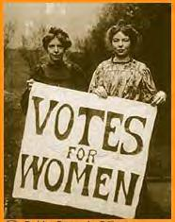

GCSE Assignment: The Changing Role and Status of Women in Britain since 1900

1. Explain why women failed to gain the right to vote between 1900 and 1914.
(10 marks)

2. ‘Without the First World War British women would not have gained the right to vote in 1918.’
Do you agree or disagree with this interpretation?
Explain your answer using the sources and knowledge from your studies.
(15 marks)
Key Words  Suffrage: the vote.  Franchise: the body of people entitled to vote  Enfranchise: give the vote.  Conciliation: compromise.  Legislation: laws  Constitution: the way the country is governed.  Source A  A woman should make a man’s home delightful. Their sex should ever teach them to be subordinate. Women are like children; the more they show they need looking after, the more attractive they are.  Mrs John Sandford, Woman in her Social and Domestic Character (1837).  Source B  Women’s Rights in the 19th century  1857: Matrimonial Causes Act – a woman can divorce her husband if he beats her or commits adultery.  1882: Married Woman’s Property Act – married women allowed to own property and to keep their own earnings.  1907: women ratepayers were allowed to vote in local elections.  Source C  Woman, as mother, sweetheart, inspirer and friend, man accepts and welcomes. But once she begins to invade his province, to do his work – then his latent jealousy will burst into flame, and everywhere there will be a great revolt.  Anti-Suffrage Review (January 1910).  Source F  We have tried every way, but we have had contempt poured upon us. Violence is the only way that we have to get the power that every citizen should have.  Emmeline Pankhurst, speaking in 1912.  Source G  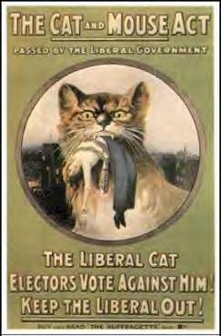  If Suffragettes went on hunger-strike, when they were very ill, the government released them. Then, when they had eaten and recovered, they were arrested again. This Act (1913) was nicknamed the ‘Cat and Mouse Act’.  Source H  Haven’t the Suffragettes the sense to see that the very worst way of campaigning for the vote is to try and intimidate a man into giving them what he would gladly give otherwise?  Lloyd George, speaking in 1913. |  |  | Nineteenth Century changes  Victorian women had few civil or political rights. A wife had to do as she was told by her husband, who was her protector and adviser. Until 1884 a wife was officially listed as one of her husband’s possessions. In addition, Victorian women were expected to live up to an image of ‘the perfect being’– beautiful, demure, loving and intelligent. Many women actively agreed with this attitude (Source A).  As the 19th century progressed, women were given a number of civil rights, including the right to vote in local elections (Source B). But by 1900 they had still not been given the right to vote in Parliamentary elections.  The Campaign  In 1866, a number of women took a petition, signed by 1,500 women and asking for the vote, to Parliament, where two of the handful of pro-vote MPs presented it. In 1897, the various women’s societies joined together into the National Union of Women’s Suffrage Societies (NUWSS). These ‘Suffragists’ as they were called, campaigned peacefully for the vote. Although the number of pro-suffrage MPs in the House of Commons grew, the Suffragists got nowhere.  In 1903, therefore, Emmeline Pankhurst formed the Women’s Social and Political Union (WSPU). The ‘Suffragettes’, as they can to be called, were much more militant. They held mass-meetings, sent deputation to 10 Downing Street, and interrupted from the Ladies Gallery during debates in the House of Commons. The Suffragettes saw the struggle for the vote as a gender-war against men.  The Opposition  Many men opposed women’s suffrage – in 1875, a Committee for Maintaining the Integrity of the Franchise had been formed in Parliament. But many women opposed it too, for many reasons (see Sources C, D and E). In 1908 the Women’s National Anti-Suffrage league was formed.  Source D  I regard women as superior and I don’t like to see them trying to become men’s equal.  Miss Violet Markham, speaking in October 1910.  Source E  I am satisfied with my present position, and of my almost unlimited power of usefulness, that I have no need of a vote, and should not use it if I had it.  Edith Milner, writing in The Times, 29 October 1906.  Failure  Private member’s bills were presented every year after 1900. They were either talked out, or passed to a Committee of the Whole House, where nothing was decided. In 1904 MPs talked for hours about tail-lights on cars, so that there would not be time for the next Bill – on women’s suffrage.  By 1908, however, most MPs, including most of the Cabinet, openly supported women’s suffrage. Asquith, the Prime Minister (who, however, did NOT agree with women’s suffrage) said that the government would bring a Bill to Parliament. In 1910 and 1911, therefore, Conciliation Bills (so-called because they only asked for the vote for one million women, so as not to annoy the opposition) were passed with large majorities. But the Bills did not become law – they were again passed to a Committee of the Whole House.  The campaign for women’s suffrage got bogged down in politics. Some MPs opposed the Conciliation Bills because they did not want ANY women to get the vote. Some pro- suffrage MPs opposed the Bills because they were too narrow. Many Liberals opposed the Bills because they thought the 1 million rich women who would get the vote would vote Conservative. After 1910, the government was faced by other crises (especially trouble in Ireland) and many MPs thought there were more important things to worry about. Many Irish MPs (there were 100 of them) voted against the Bills because they wanted more time for the Irish Question.  The Suffragettes’ reaction was to increase the violence (Source F). They burned down churches and bombed Lloyd George’s house. When arrested, they went on Hunger Strike (Source G). In 1913, Emily Davison threw herself under the king’s horse and was killed. If anything, the Suffragettes’ action turned people against Women’s Suffrage (Source H). When a third Conciliation Bill was put before the Commons in 1912, it lost by a majority of 14 votes. Then, in 1914, the First World War started, and the women’s leaders promised to stop campaigning for the vote and to help the war.  Tasks  1. Read pages 2–3 and list all the reasons you can suggest why women did not get the vote before 1914.  2. Look at the cartoons on page 4; what reasons can you infer why women did not get the vote before 1914?  3. If women were to get the vote, it would have to be given them by Parliament. Read on pages 5–8 the statements of those who spoke AGAINST the Conciliation Bill of 1912. What reasons did they give why they were against it?
Woman’s Suffrage – the Cartoonists’ View
Most of these cartoons were drawn by the anti-Suffragette cartoonist WK Haselden

 | 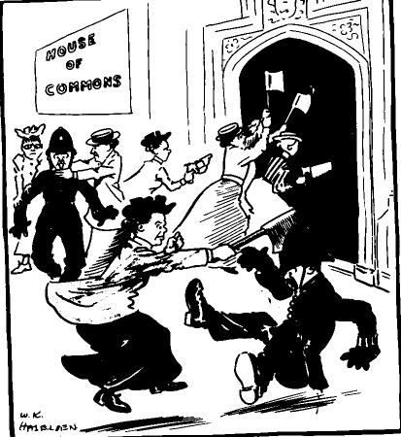  This 1906 cartoon shows Suffragettes trying to fight their way into the House of Commons. |  |  | 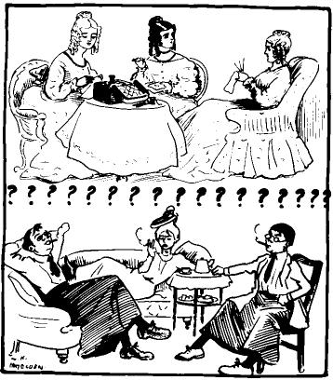  This cartoon was drawn in 1906. On the top are the women of the past; on the bottom are what women seem to be becoming. | . 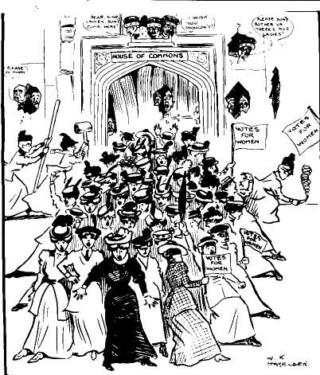  This 1907 cartoon, entitled: ‘Will they get it?’, shows women trying to pressurise their way into Parliament. The MPs shout: ‘Please don’t bother us here’.
 | 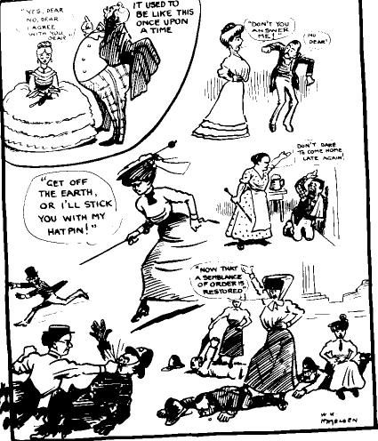  This 1907 cartoon shows women taking control over men. |  |  | 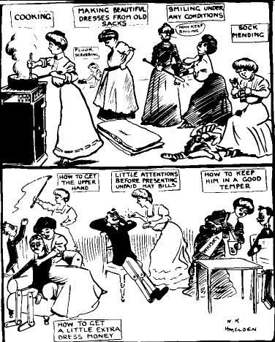  This 1907 cartoon takes a humorous look at how a good wife should behave. | 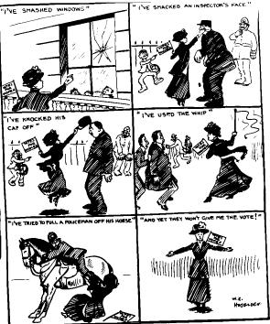  In this 1909 cartoon, the suffragette lists all the trouble she has caused, and then wonders why she still hasn’t got the vote.
 | 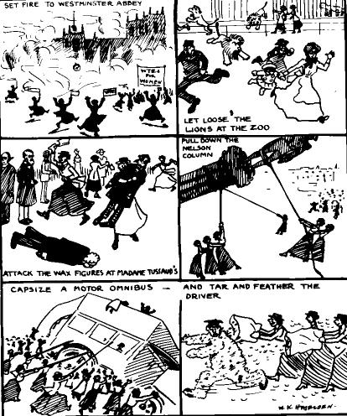  Suggestions for Suffragettes, 1909 – let the lions out at the zoo, burn down Westminster Abbey, and attack statues and buses. |  |  | 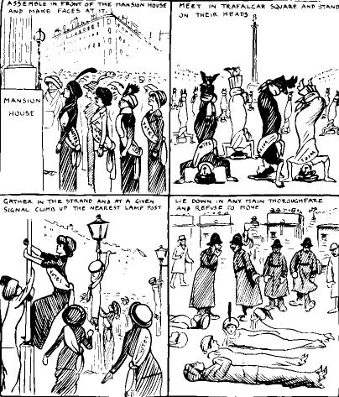  More suggestions for Suffragettes, 1913 – pull faces at politicians, stand on their heads, climb lampposts and block traffic. | 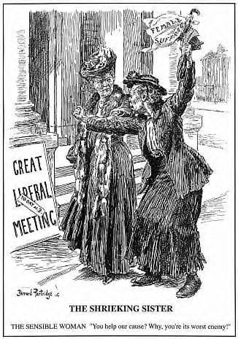  In this cartoon by Bernard Partridge the sensible woman is saying to the Suffragette: ‘Help our cause? You’re its worst enemy.’
Debate on the ‘Conciliation’ Bill, to enfranchise about 1 million Women voters, 28 March 1912
[Speakers who opposed the motion are shaded.]

1. Mr Agg-Gardiner (proposing the Bill):
I am bound to admit that within the last few weeks the prospect [for the Bill] have been dimmed and darkened by the deplorable conduct of certain person who desire to obtain its object – the enfranchisement pf women… I prefer to regard them as victims of a probably well-intentioned and perhaps earnest, but certainly misguided enthusiasm…

[Arguments against giving women the vote] are both out of date and out of place. They might have been correct and proper two or three centuries ago, when the duties of women were restricted to weaving tapestries and looking after children, but not in the twentieth century, when women have for years, by common consent, taken an active part in public affairs, when they are members of town councils, boards of guardians and Royal Commissions; when they speak on public platforms and are prominent members of political associations…

There are countless [women], some of whom have won the highest distinction in the realms of literature, of science and of art, but who are not entitled [to vote]…

2. Sir Alfred Mond (seconding the Bill):
The fact that we have in this country over 5 million women engaged in earning their own living, over 2 million engaged in industrial pursuits, surely is sufficient argument to those who still talk of setting up woman as a sort of china doll in a sacred hearth to be worshipped from afar…

Today [woman] is interested in all the widest spheres of legislation in every sense of the word. There is not a single political problem, there is not a Bill which comes before this House which does not affect millions of women…

The right Honourable Members for East Worcester is an anti-Suffragist, but he has not hesitated to address a large meeting of women on the question of Tariff Reform… If they are capable of being addressed and instructed, surely they are capable of farming an opinion… I think women have been very patient. Many people who oppose giving them the vote think nothing of asking them to go out at election times, day after day and night after night, canvassing the slums. Apparently they are quite capable of instructing men electors what to do…

We have a large number of Colonies, a number of States in America, and several European countries which have given women the vote. Am I to be told that the conditions of these countries are so very different to the conditions of this country?

To widen the sphere of influence for women is a good thing. It is good for the wife and it is good for the mother, and it is a good thing for the home of the citizen, and therefore argument against it ought to be abandoned…

It is particularly true that the mentality and ordinary emotions of women are not exactly the same as those of men. It is to my mind an advantage to the State that this is so… it would, to me mind, impoverish the State if we do not bring this section of the community into our counsels. Men take women’s advice frequently and very often they find it better than their own judgement…

Some who have voted in the past for Woman Suffrage have suddenly changed their mind. Their argument is: ‘If certain sections of those in favour of Woman Suffrage commit acts which we strongly disapprove of, therefore we will oppose the Bill, and thus punish all the other women who have done nothing at all… By committing am injustice of this kind, punishing all to penalise a few, you are doing nothing but stirring up bad feeling and committing a grave injustice.

3. Mr Harold Baker (opposing the Bill):
The exact numbers of women who were serving in public capacities [is very small]… On boards of guardians there were only 1,327 women serving out of a total of 24,824; on town councils there were only 24 women out of a total of 11,140; on urban district councils there were only 6 women out of a total of 10,561, and on county councils there were only 4 women out of a total of 4,615… It shows a very undue reluctance to take advantage of the considerable opportunities which at this moment are offered to them…

The question is not the enfranchisement of any particular class, but the enfranchisement of politically inert masses who take no interest in politics and do not desire to do so…

I think the influence of women in legislation is practically unlimited. Take the case of the pit-brow women – it happened not many years ago – by merely explaining their case in plain terms, women succeeded in avoiding what they conceived to be an injustice which was about to be inflicted on them by an Act of Parliament…

[The vote] is a badge, not of superiority, but of difference, a difference of masculine character and coercive power, a difference which is adapted for the governance of alien races and for the safeguarding of our Empire…

I think the breaking of windows has let in a good deal of fresh air on this subject… it goes to show that those who claim to have more power to persuade women are exactly those who are least fitted to exercise political power…

[There had been a postcard census of women’s opinions¹] Of the replies which have been received there are against the Suffrage 42, 793, in favour of it there are 22,176, neutral 9,404. That is the opinion of women. This is a man-made Bill which they are forcing upon the vast majority of women against their wishes…

4. Viscount Helmsley (seconding the opposition):
I maintain that the whole position and functions of Parliament would be altered… the fact of the two sexes sitting together in an assembly such as this would no doubt alter the whole tone and whole feeling of this Parliament. I do not think that any man will deny that he is conscious when he is debating in common with women of an extremely different feeling, a feeling of reserve, which is very different from the feeling which men have when they are discussing freely and debating freely with one another…

The way in which certain types of women, easily recognised, have acted in the last year or two, especially in the last few weeks, lends a great deal of colour to the argument that the mental equilibrium of the female sex is not as stable as the mental equilibrium of the male sex. The argument has very strong scientific backing… It seems to me that this House should remember that if the vote is given to women those who will take the greatest part in politics will not be the quiet, retiring, constitutional women… but those very militant women who have brought so much disgrace and discredit upon their sex. It would introduce a disastrous element into our public life… One feels that it is not cricket for women to use force… It is little short of nauseating and disgusting to the whole sex…

Government? Where are the women merchants and the women bankers? Where are the women directors of great undertakings? Nowhere to be seen at the head of the great businesses of the country. I can imagine very few undertakings in which women exercise an equal share of the control with the men…
It appears to me that it is one of the fundamental truths on which all civilisations have been built up, that it is men who have made and controlled the State, and I cannot help thinking that any country which departs from that principle must be undertaking an experiment which in the end will prove to be exceedingly dangerous…

I believe that the normal man and the normal women both have the instinct that man should be the governing one of the two, and I think that the undoubted dislike that women have for men who are effeminate and which men have for masculine women is nothing more or less than the expression of this instinct…

5. Mr McCurdy
In a civilised state of society, those who pay the taxes and have to obey the laws, should have a voice in the making of those laws… For my own part, the recent militant tactics have strengthened my desire to see a measure of Woman Suffrage placed upon the Statue Book…

6. The Prime Minister, Mr Asquith
The natural distinction of sex, which admittedly differentiates the functions of men and women in many departments of human activity, ought to continue to be recognised in the sphere of Parliamentary representation… The question: ‘Why should you deny to a woman of genius the vote, which you would give to her gardener’ {is answered in this way]. You are dealing, not with individuals, but with the masses, in my judgement the gain which might result through the admission of gifted and well-qualified women would be more than neutralised by the injurious consequences which would follow to the status and influence of women as a whole.

7. Lord Robert Cecil
The cause of Woman Suffrage is not as strong in this House today as it was a year ago, and everybody knows the cause. Everyone knows that the reason is purely and simply that certain women have broken the law in a way we all deplore…

Here are a number of citizens who discharge all the ordinary duties of citizenship. Here is this great body of citizens, and no one really will doubt that they are not quite as industrious, quite as public-spirited and quite as self-sacrificing as men. They do not ask for any privilege greater than that which man has. What they do ask for is that where they are qualified they should be entitled to vote…

8. Mr Eugene Watson
Up to the present time, and for many years past, I have voted for this question… I intend tonight to vote against this Bill. There was a meeting held at the Albert Hall on 28th February [to debate Woman Suffrage]. I believe that when these speeches were read those advocates of Woman Suffrage felt the case was put so strongly against them that they were beaten from the point of argument and that they should resort to violence… Even in this House, owing to this action, you cannot meet your wife as you used to, you cannot take your American cousin, coming over here, up to the Ladies’ Gallery. All this has been brought about by the militant Suffragists.

9. Mr Lane-Fox
There is a considerable difference between women having votes in local government and the enactment of the legislation itself. [Those women who have taken part in local government] have been administering, and not legislating. They have been carrying out the wishes of Parliament. The supreme will of the nation, the supreme government of Empire, rests in the hands of man.

The strongest reason, in my opinion, why we should not grant the vote to women is that it means the beginning of taking women away from the home into what must necessarily be the rather dirty game of politics. Everybody must know that a man without a woman to look after his home and his children is incompetent. The home cannot go on…

10. Mr Murray MacDonald
[Law is a matter of right and wrong] sanctioned solely by regard to the moral right of the individual to make the best of his own life. If a woman has the same power of deciding what is right and what is wrong as a man, in the ordinary concerns of life, I personally can see no objection to her having her full right of expressing her judgement and of determining what ought to be the nature of the laws regulating our society…

11. Mr Charles Roberts
There are some Honourable members who have a real fear of this Bill… They were wrong in 1832, and they were wrong in 1869, and there is every reason to think that they will probably be wrong in this case also… I am quite content to rest my argument in favour of the Bill upon the statement that it will enlarge the horizon of the home, and bring into the circle of citizenship a great number of those who are at present left outside.

12. Mr Stewart
Men are under the potent influence of women already. They are controlled in childhood and cherished in old age. And between childhood and old age they are more subject to their influence than at any other period of life. Women have won the Empire by sending forth their sons to do its work, and they can win any election or carry any measure they set their minds to…

13. Mr Theodore Taylor
Women claim, not as a favour, but as an inherent right as citizens if this country, a share in its government through their own votes and the ballot box… I know it is fashionable for us men to chuckle and say: ‘What superior being we are!’ I do not think we men can claim any superiority over women.

14. Mr Cator
I think the Chancellor of the Exchequer and other prominent politicians have mentioned that they believe the result of this Bill would be an advantage to the Tory party… It is certain that if the Bill is going to be a good bill for the Conservative Party the other side will never rest until they have extended the Franchise until it embraces the whole of Adult Suffrage of this country… It is because we believe that this Bill can never remain a limited measure that we fear it is exceedingly dangerous and exceedingly wrong.

15. Mr Snowden
The women who want the Parliamentary vote now are not governed by their consent, and that is a violation of the first principle of representative and democratic government. The opposition to the enfranchisement of women is not argument; it is a masculine prejudice.

I support the enfranchisement of women because I believe the active partnership of men and women in political affairs will raise politics to a higher, a holier, a purer atmosphere. I believe it will bring to the relations between men and women in the affairs of life, democratic and social, holier and worthier associations.

16. Mr Arnold Ward
Militantism and hysteria are inherent and inseparable from the Suffrage movement. They grow and progress as the Suffragist movement grows and progresses and, if this is so, then these militant outrages are a strong and serious argument against Woman Suffrage itself.

17. Sir William Byles
My firm and unshaken belief is in the emancipation of women and in the justice of electoral equality for them.

18. Mr Dickinson
I regard this question of the women’s franchise as part of the movement of civilisation.

19. Mr MacCullum Scott
The argument against Woman Suffrage which has always impressed me most is the physical force argument. First, the only stable force of government is the one which secures that the balance of political power is in the same hands as the balance of physical force. Secondly, by counting heads you secure a rough approximate index as to where government or policy has the physical force of the country behind it. In the last place, women as physical force units are not equal to men. Therefore if you include women when you are counting heads, the result is not reliable as an index of the physical force in the country… By giving votes to women you are destroying the value of a General Election.

Vote: Ayes 208, Noes 222

From Official Reports 5th Series Parliamentary Debates: Commons,
Vol xxxvi (Mar 25 – Apr 12, 1912) cols 615–732.

Lord Cecil said of this survey: ‘a canvas by post cards is an exceedingly unsatisfactory method of ascertaining anything’
Source I  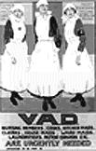  A poster recruiting nurses.  Source K  Woman cannot fight in the sense of going out with rifles and so forth, but they fill our munitions factories, they are doing the work which the men who are fighting had to do before, and they have aided in the most effective way the prosecution of the war.  Asquith, speaking in August 1916.  Tasks  1. Read Asquith’s statement (6) in the 1912 debate. Why do you think the visit of the East London women had such a big effect on him?  2. Read page 9 and list all the reasons you can suggest why women got the vote in 1917.  3. Read on pages 10–11 the statements of those who spoke FOR the Bill of 1917. What reasons did they give why they were for it?  4. Read page 12. How important was the war in getting women the vote? |  | Victory  In February 1914, Sylvia Pankhurst had fallen out with her mother and sister, and formed her own East London Federation of Suffragettes. Unlike the WSPU, it was working class, and wanted the vote as just one way to improve the condition of poor women. On 20 June, she took a deputation of East London working-class women to see Asquith.  Source J  Stout old Mrs Savoy, the brush-maker, jolly and brave… In spite of her poverty she was ever ready to share her last crust… Motherly, anxious Mrs Payne. Mrs Bird, the wife of a transport worker… Mrs Parsons, a frail little woman Mrs Watkins. Mrs Scarr, who till the advent of the Suffragettes in 1905–6 had been a ‘quiet housewife’…  They brought before the Prime Minister, in simple, moving phrases, the toilsome life of poor women. Always they returned to their demand for a place in the constitution – a vote for every woman over 21. Each woman repeated and emphasized the demand in her own fashion.  Asquith’s reply revealed an unmistakable softening in his long hostility; almost he seemed to declare himself a convert!  Sylvia Pankhurst, The Suffragette Movement (1931).  Asquith was not converted – what he said was that ‘I have listened with the greatest interest… if [women’s suffrage] has to come, we must face it boldly’. However, it was the beginning of a change in his attitudes to women’s suffrage.  During the First World War, women worked alongside men to defeated the enemy. They joined the armed forces as cook, carpenters and drivers. They served as nurses on the Western Front. At home, they worked in arms factories, and as firemen, bus drivers and navvies. Politicians, including Asquith, lined up to praise them (Source J).  1917 was a year of crisis for the government. The battle of Passchendaele was going badly, and the French soldiers mutinied, threatening to take the French out of the war altogether. People – particularly those men soldiers who did not have the vote because they were not ratepayers – were asking what was in the war for them. The government had to look to maintaining morale, and began to speak about making ‘a land fit for heroes’ when the war was over.  In 1917, the government decided to give the soldiers the vote. The women suffragist societies demanded that they, too, be included. In May 1917 the Representation of the People Bill passed the Commons by a large majority, and in 1918 it became law, giving the vote to women over the age of 30.
Debate on the Representation of the People Bill (22-23 May 1917), to enfranchise all men, and women voters over the age of 30
[Speakers who supported the motion are shaded.]

1. Sir G Cave (proposing)
Perhaps I may be allowed to put this one question to members who hold strong views on this matter, namely, whether it is possible for us – having called upon women for so large a contribution to the work of carrying on the War, and having received so splendid a response to that call – to refuse to women a voice in moulding the future of the country which their help and devoted self-sacrifice have done so much to save?

2. Colonel Saunders
Women’s franchise is doubly necessary now, not just out of gratitude for what they have done in the course of the War, but I think in mere justice. One thing that one notices all over the country is that women are now taking the place of men. When the men come back the question must arise as to whether the women are to stay or the men to come in. How those questions are to be settled I do not know; but I do say that it is only just and fair that the women should have a voice in settling it.

3. Colonel Archer-Shee
The women preponderate greatly over the men – before the War I think the excess of women over men was nearly 1,500,000. Therefore, by giving women the vote, you give them the main political power.

Hon. Members talk about women having earned the vote, but they do not want it. Why give them something they do not want?

There are certainly a number of people who think that men should decide peace and War, and the preparations you make for them. I do not think it is a matter for women.

This is all being done during a time of War, when we have immensely more important questions to think of.

4. Lord Hugh Cecil
Women have already the municipal franchise and their possession of it has not made any difference in local matters… I do think that the controversy about women’s suffrage is a miserable one. The argument is increasingly used as to the controversy between the two sexes; it is the most intolerable that we can conceive, and a question of that kind is much better brought to a close as soon as possible.

5. Sir J Simon
Opposition [to women’s suffrage] has largely faded away… The House really desires to create a House of Commons, representative both of men and women, which will be the means by which we may make good the result that will follow victory in the field.

6. Mr Cochrane
In my opinion the case for the extension of the franchise to women has been enormously strengthened during the last three years. In the first place, it is due to the conspicuous service that women have given to the nation during the War… it would have been impossible to have carried on the War without them. The second cause which has contributed to this change of feeling, I suggest, is the total abstinence from those militant methods which, I believe, did far more damage to their cause then their strongest opponents ever realised.

I am aware that the leaders of the movement for women’s suffrage do not appreciate the achievements of women being regarded as an excuse for granting the franchise. I received a deputation, and when I gave that as a reason I was told that women demanded the vote as a right. Well, I cannot help thinking that if the great work which women have done in the War has been the means of converting some of us who were lukewarm, or perhaps even hostile, then women may well accept support from whatever cause it is forthcoming.

7. Sir W Bull
I have been a suffragist all my life, and I have been a persistent supporter of the movement.

8. Mr Ramsey MacDonald
From my point of view I do not believe that the War has contributed one single new argument in favour of women’s suffrage. Anybody who has entered intimately into the great concerns of life, the life of the home, the life of the State, and the life of the citizen, must have known long ago of the magnificent part and the essential part that woman has been playing... So far as service to the nation is concerned, what would our nation have been without the service that women were giving long before the War broke out? That is a very tardy recognition of the obligation that this nation is under to the woman worker, and I am very glad that the War at any rate should be made the excuse and the occasion for that recognition being embodied in a franchise act.

9. Sir H Craik
I see great difficulties as regard female suffrage… We are told: ‘You must accept this because it will end most troublesome questions’. Do hon. Members think that if you pass this bill all the elements that draw us one from another will disappear?

10. Mr Wilson-Fox
I understand that, if the women’s age be fixed at 30 there would be an addition of 6 million female voters to the electorate. That, I would say, goes a great deal further than a limited experiment. It is a very great plunge, and I for one think that the plunge is far too great.

11. Captain O’Neill
I was opposed to women’s suffrage previous to the War… because of the most unfortunate and disgraceful campaign with which it was urged… I must confess that the general conduct of women during this War, and the fact that they have undertaken physical duties which I personally should have thought it impossible for them to carry out, have caused me to change my view.

12. Sir F Banbury
It is stated that women have done so well in the War that many people have changed their opinion. Who expected women not to do well in the War? That is the character of woman. She is always like that. When we are in pain and trouble, when pain and anguish wring the brow, they are ministering angels, and when we know that in our hours of ease they will be uncertain, coy, and hard to please, why is it that we are to surrender the future government of this country into their hands?

13. Mr Dickinson
We have been for many years, I will not say jockeyed, but disappointed by the various difficulties in this House. Therefore I feel very grateful to the Government for having put the Clause into the Bill and freed us from all difficulties of procedure or points of order. I hope that the House will at last put an end to what has been, in my opinion, a crying injustice, namely, the total denial to woman of Parliamentary power in this country.

14. Col. Lord H Cavendish-Bentinck
I do not base the claims for women on the work which they have done during this War. I base the claims for women on higher grounds than that. If our religion has not taught us the equal value of men and women in the eyes of the Maker, then our religion has taught us very little indeed. Women have a right equally with men to co-operate in the framing of society Are we to treat women as drudges or as citizens? I feel very strongly that they have a right to be treated as citizens, and that is why I give my support to this Bill.

Vote: Ayes 329, Noes 40

From Official Reports 5th Series Parliamentary Debates: Commons
Vol xciiii (Apr 30 – May 25, 1917) cols 2133–2253, 2323–2444

Did the War get Women the vote?

Source L
Constance Rover – YES!
It is frequently said that women were given the vote ‘because of the war’… The war changed the situation in more ways than are obvious at first sight. The obvious effect was that women’s contribution to the war effort was seen and appreciated and that women, instead of being subjected to frequent criticism in the press and by public figures, were very generally praised. Public opinion became overwhelmingly favourable towards women.

Public opinion also became more democratic generally, as the shared hardships created a more equal society and lessened the emphasis on class divisions. There was a general desire that sacrifices should not be in vain and that a better world should come out of the war. Surely a land fit for heroes to live in might include a place for a few heroines as well?

The war emphasised the participation of women in the everyday life of the nation. It was obvious to all that women were driving vehicles, acting as bus conductors and filling many posts customarily held by men. As we might say today, women’s ‘public image’ changed and improved.

Besides these obvious changes, the war transformed the political situation… It was obvious that the campaign would recommence once the war was over if nothing was done to enfranchise women. It would have been extremely embarrassing and probably unpopular as well to imprison women who had played such an important part in the war effort.
Constance Rover, Women’s Suffrage and Party Politics in Britain 1866–1914 (1967)

Source M
Paula Bartley – NO!
It would be naïve to believe that women received the vote solely for services rendered in the First World War. It must be remembered that only women over 30 were given the vote and the very women who had helped in the war effort – the young women of the munitions factories – were actually denied the vote. The significance of women’s war work in the achievement of the vote is therefore perhaps not as great as first assumed. In reality, women were greatly resented in both agriculture and industry… Men ‘froze out’ women workers, gave them no help and even sabotaged their work… The reasons for the shift which took place in Government thinking therefore need consideration.

First and perhaps most importantly, there was a need for franchise reform in general. Large numbers of soldiers were ineligible to vote. This of course would not do.

Secondly, there were a number of changes in Parliament which altered the balance between those who opposed and those who were in favour of votes for women. Several suffragist MPs were promoted to the Cabinet. More importantly Lloyd George, who was sympathetic to women’s suffrage, replaced Asquith as Prime Minister in December 1916.

Thirdly, the war allowed a number of hostile MPs – Asquith in particular – the excuse to climb down. These MPs, though not converted to women’s suffrage, realised that reform was inevitable and used women’s war work as a pretext to change. Asquith’s remarks about the female electors of Paisley in 1920 suggest he still resented women’s involvement in Parliament – ‘a dim lot, for the most part hopelessly ignorant of politics’.

Fourthly, in May 1915, the Liberal government became a Coalition government. The old fears that one party might benefit from women’s suffrage were laid to rest

Finally, Britain was merely reflecting an international trend towards full democracy. Women in New Zealand, Australia, Finland, Denmark and Norway had already been enfranchised… It would have been a peculiar embarrassment if the mother of democracy, Britain, lagged behind other countries.
Paula Bartley, Votes for Women 1860–1928 (1998)

AQA Sources

Source a: The importance of the vote.
It is important that women should have the vote so that, in the government of the country, the woman’s point of view can be put forward. Very little has been done for women by legislation for many years.
You cannot read a newspaper or go to a conference without hearing details for social reform. You hear about legislation to decide what kind of homes people are to live in. That surely is a question for women.
No woman who joins this campaign need give up a single duty she has in the home. It is just the opposite, for a woman will learn to give a larger meaning to her traditional duties.
From a speech made by Mrs Emmeline Pankhurst in March 1908.

Source b: An argument in favour of votes for women
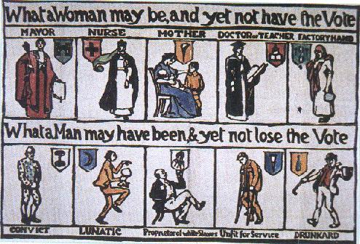

Source c: An argument against votes for women.
Women do not have the experience to be able to vote. But there are other problems as well: the way women have been educated, their lack of strength, and the duties they have.
I women did gain the vote, it would mean that most voters would then be women. What would be the effect of this on the government? I agree that there are some issues upon which the votes of women might be helpful. But these cases do not cover the whole of political life.
What is the good of talking about the equality of the sexes? The first whiz of the bullet, the first boom of the cannon and where is the equality of the sexes then?
From a speech made in 1912 by Lord Curzon, a Conservative leader.

Source d: men and women united in a common cause
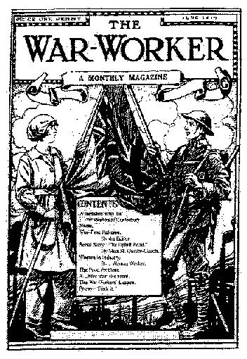
The cover of the War Worker magazine, June 1917

Source e: Male attitudes to women workers during the First World War
Attitudes to women workers remained, in many cases, negative. The ability of women to take on that had been men’s work meant that increasing numbers of males were vulnerable to conscription.
Some women doing skilled work had the full co-operation of male employees. Many other women were restricted to less skilled work and were victims of hostility and even of sabotage.
From War and Society in Britain 1899–1948, by Rex Pope, an historian, 1991.

