The League of Nations

In this module you will learn:

The FOUR aims of the League of Nations [SIDE].
How many members the League had in 1919 and in the 1930s.
The names of THREE countries who weren’t members of the League (and why).
the four main members of the league.
Four strengths of the League.
THREE weaknesses of the League.
FOUR powers of the League.
EIGHT parts of the League’s organisation.
NINE successes of the League in the 1920s.
FOUR failures of the League in the 1920s.
TWO failures of the League in the 1930s – and their effect on the League.
SEVEN reasons why the League failed in the 1930s [WAS DUMB].

You must do the following written work:

A spidergram showing the main aims of the League.
Written notes on the League’s powers.
Written notes on the League’s organisation.
An essay: ‘How strong was the League of Nations?’
Written notes on the work done by the League.
Written notes on Manchuria, 1931
Written notes on Abyssinia, 1935
A 35-word ‘last word’ comment on the League.
Written answers to 15 questions on the League.

Have you read:
Peter Moss, History Alive 4, page 29.
T Rea and J Wright, International Relations, chapter 4.
Christopher Culpin, Making History, chapter 11.
J Traynor and I Dawson, The Struggle for Peace, chapter 5.
N deMarco and R Radway, The Twentieth Century, pages 148–155.

Source A  It is not enough just to win the war. We must win it in such a way as to keep the future peace of the world.  President Wilson, talking in 1918.  Tasks  1. Work in threes. Take it in turns to imagine you are Wilson, talking to Clemenceau and Lloyd George. Tell them about your idea for the League of Nations, what it would do, and how it would work.  3. Study Source B  What effect would America’s refusal to join have upon the League, did the artist think? |  |  |  | The League of Nations  The League of Nations was set up because President Wilson wanted this more than anything else.  He wanted the League to be a kind of ‘world parliament’, where nations would sort out their arguments. He hoped this would stop wars. But Wilson wanted to do more than just stop war; he wanted to make the world a better place. He wanted the League to do things to improve people’s lives and jobs. He wanted to improve public health, and to end slavery.  Wilson also hoped that the League would persuade the nations to agree to disarmament – to put down their weapons. That would make war impossible.  Finally, Wilson thought that the League of Nations could enforce the Treaty of Versailles, and persuade countries to keep the promises they had made.  Task  Draw a spidergram of the FOUR aims of the League of Nations.  Were the League’s aims impossible, do you think?.  America Pulls Out  But when Wilson got back home to the United States, the American Senate refused to join the League.  Americans did not want to get dragged into other countries’ problems. This damaged the League a lot
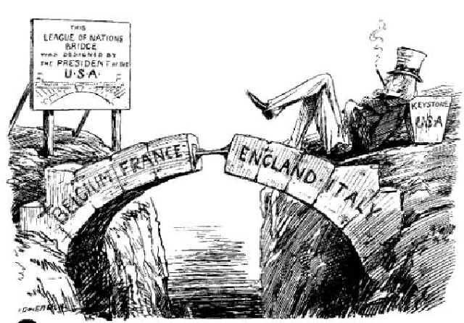
⬆ Source B
‘The Gap in the Bridge’ – a British cartoon of 1919 – shows America refusing to join the League.
 | Strengths & Weaknesses  Forty-two countries joined the League at the start. In the 1930s about 60 countries were members. This made the League seem strong.  However, the most powerful countries in the world were not members. The USA did not want to join. The Russians refused to join – they were Communists and hated Britain and France. Germany was not allowed to join. Without these three big powers, the League was weak.  Britain and France were the main members, helped by Italy and Japan; they were quite powerful countries. Also, the League had four powers it could use to make countries do as it wanted (see Source A). Theoretically, the League was allowed to use military force, but the League did not have an army of its own – so if a country ignored it, in the end, there was nothing the League could do.  The main strength of the League was that it had been set up by the Treaty of Versailles, and agreed by everybody at the conference.  The biggest weakness was that the League’s organisation was a muddle (see Source B). The different parts of the League were supposed to act together; but in a crisis, no-one could agree.  Tasks  1. Using the seven sentences in bold in the passage above, sort out the League’s ‘strengths’ and ‘weaknesses’. Compare the two lists.  2 People at the time used all these phrases to explain how they thought the League would influence countries:  - Collective Security  - Community of Power  - Moral Persuasion.  For each, discuss what you think people meant.  3. Did the League have any chance of keeping world peace? |  |  |  |  |  |  |  | Source A – Powers  1. Covenant (in the League’s Covenant, especially Article 10, all members had promised to keep the peace).  2. Condemnation (the League could tell a country it was doing wrong).  3. Arbitration (the League could offer to decide between two countries).  4. Sanctions (stopping trade).  Source B – Organisation  1. Assembly (the main meeting o the League – all members met once a year). Its main problem was that decisions had to be unanimous, which was very difficult to achieve.  2. Council (a small group of the more important nations – Britain, France, Italy and Japan plus some other countries – met 4–5 times a year).  3. Agencies (committees of the League):  - Court of International Justice (for small disputes).  - Health (to improve world health).  - International Labour Organisation (to try to get fair wages).  - Slavery (to end slavery)  - Refugees.  4. Secretariat (was supposed to organise the League, but failed).  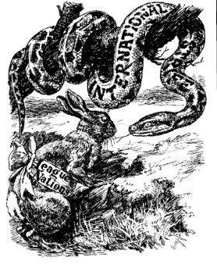  ⬆ Source C  ‘Moral Persuasion’ – a cartoon of 1936. What was it saying about the League?

Did the League stop wars in the 1920s?

The main aim of the League of Nations was to stop wars. In the 1920s, there were many small disputes between countries, which the League tried to solve. This spread looks at just two disputes (you will need to research other incidents). Did the League manage to stop wars in the 1920s? Decide if you think the League was a success or a failure.

 | Corfu, 1923  The Dispute:  An Italian general was killed while he was doing some work for the League in Greece. The Italian leader Mussolini was angry with the Greeks. He invaded the Greek island of Corfu.  The Greeks asked the League to help.  What the League did:  The Council of the League met. It condemned Mussolini, and told him to leave Corfu.  It told the Greeks to give some money to the League.  What happened:  Mussolini refused to accept its decision. He refused to leave Corfu.  The League changed its decision. It told Greece to apologise to Mussolini, and to pay the money to Italy.  The Greeks did as the League said. Then Mussolini gave Corfu back to Greece.  Tasks  1. Discuss as a whole class:  a. Was the League successful in Corfu?  b. Was the League successful in Bulgaria?  2. In 1925, Greece complained that there seemed to be one set of rules for small countries such as Greece, and a different set of rules for big countries such as Italy. Do you agree?  3. Did the League’s actions add to its standing, or detract from it, do you think? |  |  |  |  |  |  | Bulgaria, 1925  The Dispute:  Some Greek soldiers were killed in a small fight on the border between Greece and Bulgaria. The Greeks were angry. They invaded Bulgaria.  Bulgaria asked the League to help.  What the League did:  The Council of the League met. It condemned the Geeks, and told them to leave Bulgaria.  What happened:  The Bulgarian government sent orders to its army not to fight back.  The Greeks did as the League said. They left Bulgaria.  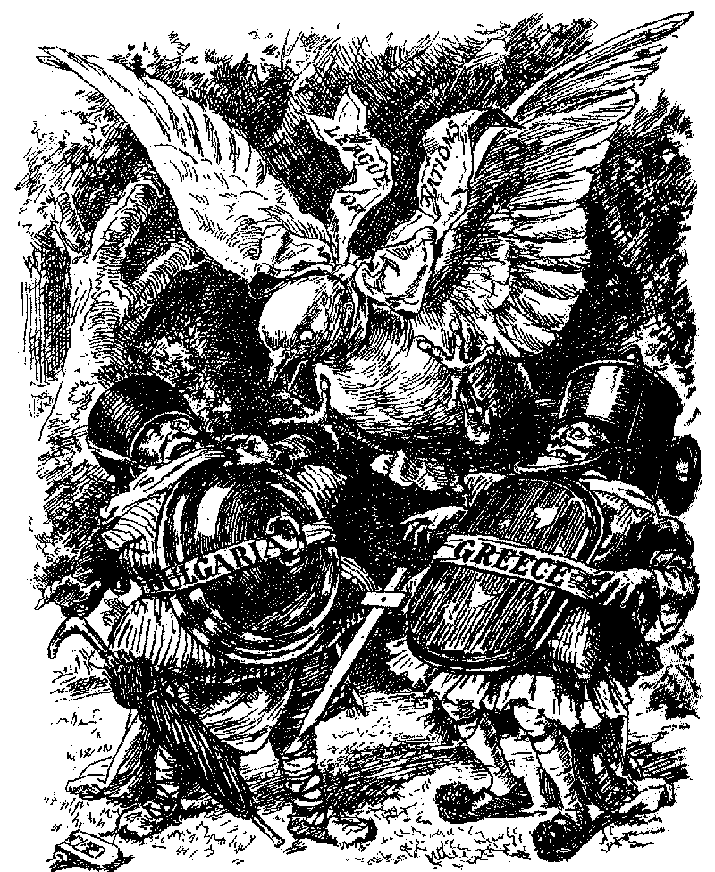  ⬆ Source A  A British cartoon of 1925 shows Greece and Bulgaria fighting – like Tweedle-dum and Tweedle-dee in the story Alice in Wonderland.  The League, like the dove of peace, stops the fight.
 |  | Was the League successful in the 1920s?
 |  | This spread looks at the League’s work: boxes a–m on this page describe some of the work done by the League in the 1920s.  The League of Nations had four aims:  - Stop wars,  - Improve people’s lives and jobs,  - Disarmament,  - Enforce the Treaty of Versailles.  In the last spread, you looked at the League’s work to stop wars..  You will be able to decide if you think the League was a success or a failure.  a. Bulgaria (1925)  Greece obeyed the League’s orders to pull out of Bulgaria in 1925.  b. Poland (1920)  Poland took land from Russia, breaking the Treaty of Versailles. The Poles ignored the League’s order to stop  c. Slaves  The League attacked slave traders in Africa and Burma and freed 200,000 slaves.  d. Disease  The League worked to prevent malaria and leprosy.  e. Disarmament (1932)  Disarmament talks failed, because Germany demanded as many weapons as everyone else.  f. Prisoners of War  The League took home half a million World War One prisoners of war.  g. Reparations (1921)  When the Germans refused to pay, France and Britain invaded Germany and made them pay. |  |  |  |  |  |  |  | Tasks  - Divide boxes a–m up into ‘successes’ and ‘failure’s. Overall, was the League a success or a failure in the 1920s?  - Divide up the boxes again, this time into the four kinds of work done by the League.  - Stopping wars,  - Improving lives and jobs,  - Disarmament,  - Enforcing the Treaty of Versailles.  Share your answers as a whole class. Copy up notes on ‘The Work of the League in the 1920s’, under the four sub-headings. Colour the titles: one colour for the League’s ‘successes’, another colour for its ‘failures’.  h. Jobs  The International Labour Organisation failed to persuade countries to adopt a 48-hour week.  i. Economic problems  The League sent economics experts to help Austria and Hungary.  j. Kellogg-Briand Pact (1928)  Sixty-five countries signed the treaty to end war – but just ignored it.  k. Refugees (1922)  The League set up camps and fed Turkish refugees.  l. Corfu (1923)  Mussolini ignored the League’s orders to pull out of Corfu in 1923, and made Greece pay money to Italy.  m. Drugs  The League closed down four big companies which were selling drugs.

 | The League’s Failures in the 1930s  In the 1920s, the League of Nations had been quite successful. In the 1930s, it failed terribly.  This spread looks at the League’s two main failures in the 1930s – in Manchuria and Abyssinia.  By 1935, most countries did not think that the League could keep the peace.  When Hitler began to break the Treaty of Versailles in the 1930s, the League was powerless to stop him (this is the next topic you will study).  The league failed, and the only way to stop Hitler was a Second World War.  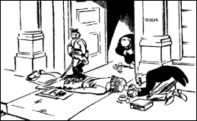  ⬆ Source A  A British cartoon of 1933 shows Japan trampling all over the League, whilst Britain powders her nose. Other cartoons made the same point.  Tasks  1. Read the stories about Manchuria and Abyssinia. From the stories, can you work out WHY the League failed there?  2. Read Sources B–D. Did the Abyssinian crisis ‘kill’ the League?  3. Who gained most from the Manchurian and Abyssinian crises? |  | Manchuria, 1931  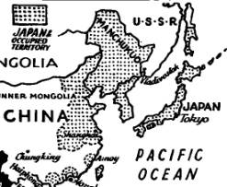  The Dispute: (pages 205-207)  In the 1930s there was a world-wide economic depression. Japan tried tp overcome the depression by building up an empire.  In 1932, the Japanese army invaded Manchuria, threw out the Chinese, and set up their own government there.  China asked the League to help.  What the League did:  The League sent officials to study the problem (this took a year).  In February 1933 it ordered Japan to leave Manchuria.  What happened:  Japan refused to leave Manchuria. Instead, Japan left the League.  Many countries had important trading links with Japan. The League could not agree on sanctions or even a ban on weapons sales. Britain and France did not want a war, so nothing was done.  The Japanese stayed in Manchuria.  The League had failed.
 | Abyssinia, 1935  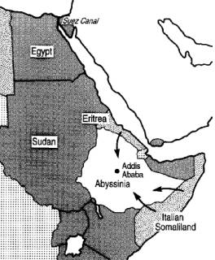  The Dispute: (pages 205-207)  Mussolini got ready to invade Abyssinia (Ethiopia). He wanted war and glory.  Abyssinia asked the League to help.  What the League did:  The League talked to Mussolini – but he used the time to send an army to Africa.  The League suggested a plan to give part of Abyssinia to Italy.  What happened:  Mussolini ignored the League, and invaded Abyssinia.  The League banned weapons sales, and put sanctions on rubber and metal.  It did nothing else – in fact Britain and France secretly agreed to give Abyssinia to Italy.  Italy conquered Abyssinia  The League had failed. |  | Source B  The crisis was fatal to the League. Nobody took it seriously again. They got ready for the Second World War.  Written by the historian JR Western (1971).  Source C  After Manchuria and Abyssinia, people decided that it was no longer any use putting their hopes in the League.  Written by the historian J Joll (1976).  Source D  The League died in 1935. One day it was a powerful body imposing sanctions, the next day it was a useless fraud, everybody running away from it as quickly as possible. Hitler watched.  Written by the historian AJP Taylor (1966).  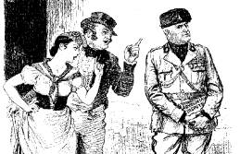  ⬆ Source E  A British cartoon of 1935 shows international politics like a stage musical. Britain and France sing:  ‘We don’t want you to fight,  but by jingo if you do,  We will probably issue a joint memorandum  Suggesting a mild disapproval of you.’
Task  Go back and look at pages 2–7. Study them carefully. Working as a whole class, make a spidergram of ideas why the League failed.  Now read the passage below and see how many ideas you got.  Why the League Failed  The League failed in Manchuria and Abyssinia because it WAS DUMB!  Weak – the League’s ‘powers’ were little more than going ‘tut-tut’. Sanctions did not work. It had no army.  America – the strongest nation in the world never joined.  Structure – the League was muddled, so it took ages to do anything. Members couldn’t agree – but decisions had to be unanimous. This paralysed the League.  Depression – the world-wide Depression made countries try to get more land and power. They were worried about themselves, not about world peace.  Unsuccessful – the more the League failed, the less people trusted it. In the end, everybody just ignored it.  Members – the League’s main members let it down. Italy and Japan betrayed the League. France and Britain did nothing to help it.  Big bullies – in the 1920s, the League had dealt with weak countries. In the 1930s, powerful countries like Germany, Italy and Japan attacked weaker countries. They were too strong for the League to stop them.  Tasks  1. Read the passage, ‘Why the League Failed’, and learn the mnemonic WAS DUMB.  2. Think about the seven reasons why the League failed. Working as a whole class, for each reason, suggest an explanation of how that reason might have caused the failure of the League.  3. Read Source A. It is HAL Fisher’s ‘last word’ on the League (he used 35 words). Looking back through this unit, write your own ‘last word’ on the League, taking 35 words. Read your comment to the rest of the class. |  |  |  |  | Source A  If the nations want peace, the League gives them the way by which peace can be kept.  But, League or no League, a country which is determined to have a war can always have it.  The historian HAL Fisher, writing in 1935.

Revision Questions

- Why was the League of Nations set up in 1919?
- What Treaty set up the League of Nations
- What were the four aims of the League of Nations?
- What happened when Wilson went back home to America?
- Why did the Americans not want to join the League of Nations?
- How many countries joined the League of Nations in 1919?
- How many members did the League have in the 1930s?
- Name three powerful countries which were not members of the League.
- Why was Russia not a member of the League?
- Why was Germany not a member of the League?
- Who were the four main members of the League?
- What four powers did the League have to enforce its decisions?
- Explain the following:
Covenant Condemnation Arbitration Sanctions
- What did the League NOT have which made it very hard for it to enforce its decisions?
- What were the eight main parts of the League’s organisation?
- How many times a year did the League’s ‘Assembly’ meet?
- How many times a year did the ‘Council’ meet?
- What did the ‘Court of International Justice’ do?
- What did the ‘Health Committee’ of the League do?
- What did the ‘Slavery Committee’ of the League do?
- What did the ‘Refugee Committee’ of the League do?
- What was the job of the Secretariat’?
- Which two countries were involved in the Corfu dispute of 1923?
- Who was the leader of Italy?
- Which two countries were involved in the Bulgaria incident of 1925?
- How many prisoners of war did the League get home?
- In which country did the League set up a refugee camp?
- Which two diseases did the League try to destroy?
- How did the League try to say no to drugs?
- How many slaves did the League set free?
- Which two countries did the League send economics experts to?
- What did the Kellogg-Briand Pact promise in 1928?
- How did Britain and France make Germany pay reparations in 1921?
- What did the League try to arrange at its disarmament conference?
- Why did the Disarmament Conference of 1931 fail?
- Which country broke the Treaty of Versailles by attacking Russia in 1920?
- What did the League’s ‘International Labour Organisation’ try to do?
- Which country invaded Manchuria in 1931?
- What was the ‘economic depression’ of the 1930s?
- Why didn’t France and Britain try to force Japan to leave Manchuria?
- Which country did Italy invade in 1935?
- What did Britain and France secretly agree with Italy?
- What effect did the League’s failures in Manchuria and Abyssinia have?
- List seven reasons the League failed.

