Britain and World War II

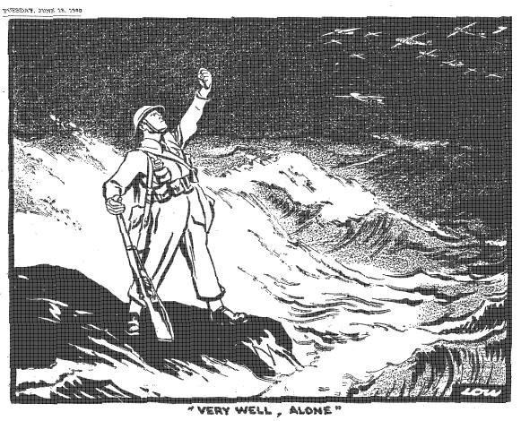

In this module you will study:

- The Phoney War
- Evacuation
- Dunkirk
- The Battle of Britain
- The Blitz
- Conscription
- The Battle of the Atlantic
- D-Day
- Censorship and Propaganda
- Internment
- The role of Women in the War
- Rationing

The Phoney War  Dawn: This Phoney war gets on my nerves. If we’re going to have a war, I wish they’d get it started.  Mum: Just ignore her.  Hope and Glory  By the end of September, Germany and Russia had defeated Poland. Everyone expected Hitler to attack western Europe with his ‘blitzkrieg’ tactics, but nothing happened (indeed, on 6 October, Hitler offered peace).  Meanwhile, Britain and France made no effort to attack Hitler. A British Expeditionary Force of four divisions – 158,000 men with 25,000 vehicles – left for France on 11 Sept, but it was too small and poorly-equipped to challenge the Nazi army. And France’s strategy was dominated by the Maginot line, an defensive super-trench on the border, which French generals believed would keep France safe from Nazi attack).  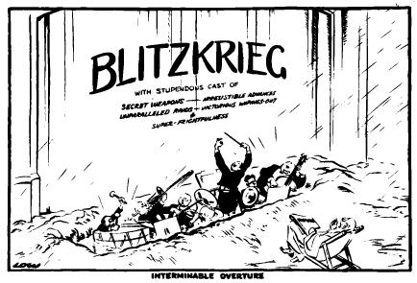  Source B  This David Low cartoon in the Evening Standard (31 October 1939) showed the German war effort – despite its ‘secret weapons’ and ‘super-frightfulness’ as an ‘Interminable Overture’ (the music before the show starts.  The period came to be called ‘the phoney war’. Britain was able to consolidate its preparations for war (Source A). Barrage balloons were deployed to force the Luftwaffe to fly higher – so their bombing would be less accurate. Pillar boxes were painted with yellow gas-sensitive paint (38 million gas-masks has been distributed during 1939 – cinemas refused admission to people without a gas-mask). 400 million sandbags were piled round the entrances to shops and public buildings. London zoo put down all its poisonous snakes, in case they escaped during a bombing raid. There was a wedding boom, as many couples married hurriedly before the man was called up – one man committed suicide when he found out he was too old for national service. The Queen told women: ‘You are talking your part in keeping the Home front stable and strong’, urging them: ‘we, no less than men, have real and vital work to do’. |  | Source A  3 Sept: 827,000 children and 535,000 pregnant mothers have been evacuated from the towns to the country.  4 Sept: a Nazi U-boat sinks the SS Athena – 112 passengers died.  9 Sept: RAF drops 12 million propaganda leaflets on Germany.  15 Sept: the first convoy sets sail from Canada.  22 Sept: petrol rationing.  30 Sept: The Nazi cruiser the Graf Spee sinks a British cargo ship.  10 Oct: 25,000 women join the Women’s Land Army.  20 Nov: the Nazis drop magnetic mines, which start to sink British shipping.  17 Dec: Graf Spee destroyed.  31 Dec: revellers shining torches are arrested.  1 Jan: 2 million men aged 20–27 are called up.  8 Jan: butter, sugar and bacon are rationed.  22 Jan: newsreels censored.  30 Jan: a national campaign is organised to collect scrap metal, paper, and food waste (for pig-swill).  6 Feb: Ministry of Information launches its ‘Careless Talk Costs Lives’ campaign.  12 Feb: paper rationed.  11 March: meat rationing.  3 Apr: Lord Woolton appointed Minister of Food  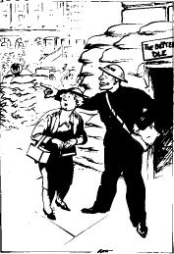  Source C  This Evening Standard cartoon of 18 Sept 1939 shows a woman, lost among the sandbags, needing directions from an ARP warden.
By Spring 1940, many people had decided that war was never going to happen, and they followed the advice of the newspaper headline which suggested: ‘Forget Hitler – take your holiday’. They stopped carrying their gas-masks. Six million people every night tuned in to listen to ‘Lord Haw-Haw’, the British Nazi who broadcast on the wireless from Germany…  … until, suddenly, on 9 April 1940, Nazi forces attacked Denmark and Norway.  Tasks  1. Was Britain serious about the war Sept 1939– April 1940? Support your answer with evidence from Source A.  2. What can an historian learn from sources B and E about British attitudes to the Nazis during the Phoney War?  3. What does Source C suggest about the degree to which people’s lives were changed?  4. How useful is Source D in telling us about British attitudes during the Phoney War? | 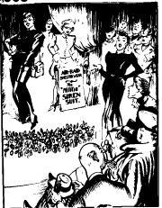  Source D  ‘Utility’ clothing used less cloth. This Lee cartoon in the Evening News of 4 October 1939 comes from a series called ‘Smiling Through’.  It shows a woman modelling the ‘utility’ siren suit. The man’s wife turns to him as says: ‘Well, that settles it, James. In the case of an air-attack, you do NOT participate!"
 Source E
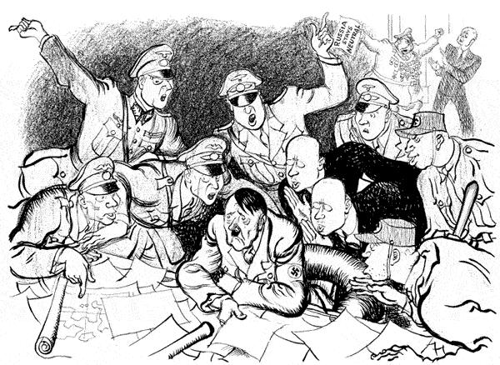This Illingworth cartoon of 2 November 1939 shows an unhappy Hitler assailed by doubts, while his adviser shout encouragement: ‘Why not an offensive today?... Wait until the spring .. Russian gold is behind us... Germany is bankrupt... Why not bomb Britain?... there might be reprisals...’

Evacuation  The government knew that cities would be bombed, and thought that gas would be used. A million coffins were prepared. It was feared that many child casualties would affect morale, so pressure was put on parents to send the children away to the safety of the countryside.  Families gathered at railway stations. A label was tied to the children giving their destination. The evacuations began on 1st September 1939. Some parents refused to allow their children to leave, but amazing numbers sent them away. Over one million evacuees left London by train.  School children travelled with their teachers. Children under five went with their mothers. Pregnant women were also evacuated For many children the journey was exciting, they had never seen the country before. It was the first time they had seen farm animals. For many others it was the first time they had been away from home and they were very distressed.  Source C  A teacher remembers being evacuated with children from her school  All you could hear was the feet of the children and a kind of murmur, because the children were too afraid to talk. Mothers weren't allowed with us, but they came along behind. When we got to the station the train was ready. We hadn't the slightest idea where we were going and we put the children on the train and the gates closed behind us. The mothers pressed against the iron gates calling, 'Good-bye darling'.  from an interview in 1988 with a teacher  Many evacuees felt homesick. Strangers chose them and took them to live in their homes. They went to the local school and had to make new friends. Some ended up with brutal or dirty carers. The country was different to city life. Some never settled down in their new homes.  Others – such as the comedian Kenneth Williams – were happier with their new families than they had been at home. Very young children sometimes forgot their real parents.  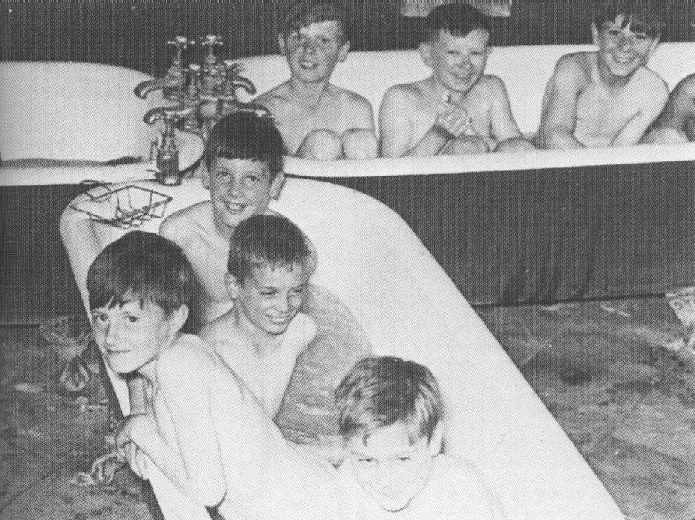  Source D  Evacuees enjoying a bath – again, a photo published with government permission. This picture was published in London, where the children’s mothers lived.  Country people found the city children hard to cope with. They were horrified by their ignorance – for instance, many were amazed to find out that milk came from a cow. Many evacuees were poor – they had never worn underclothes, eaten food from a table or slept in a bed. Some were filthy and naughty. Many wet the bed.  Source E  The mother of a host family looks back  The children went round the house urinating on the walls. Although we had two toilets they never used them. Although we told the children and their mother off about this filthy habit they took no notice and our house stank to high heaven.  from an interview in 1988 with the mother of a host family  There was no bombing between September and Christmas so many parents took their children home again. Some children were evacuated again the next year and some stayed in the country the whole of the war.  The immediate reaction of families, faced with a wild, filthy urchin, was to blame the parents. In time, however, they realised that poverty, rather than parenting, was to blame. For many middle-class people, it was the first time they had seen poverty at first hand. In this way, evacuation was one of the factors which led the people of Britain to demand a Welfare State after the war. | 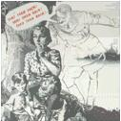  Source A  Government propaganda put immense pressure on parents to send their children to the ‘safety’ of the countryside. In this poster, Hitler is a ghostly figure whispering ‘Take them back’.  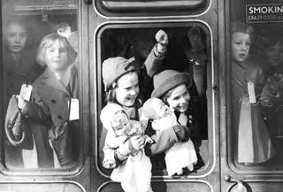  Source B  Evacuees on a train out of London, September 1939. All photographs like this were censored by the government before they were released.  Source H  Relations between evacuees and host families  Many children, parents and teachers were evacuated when war was declared. The evacuees were received at reception centres and then placed with local families. Arrangements, however, did not always go smoothly. Unfortunately many evacuees could not settle in the countryside. The country people were shocked at the obvious poverty and deprivation of the town children, not to mention their bad manners. There were reports of children 'fouling' gardens, hair crawling with lice, and bed wetting.  D Taylor, Mastering Economic & Social History (1988)  David Taylor is a modern historian.  Source F  An evacuee looks back  How I wish the common view of evacuees could be changed. We were not all raised on a diet of fish and chips eaten from newspaper, and many of us were quite familiar with the origins of milk. It is just as upsetting for a clean and well-educated child to find itself in a grubby semi-slum as the other way round.  from an interview in 1988 with someone who was an evacuee in 1939  Source G  An extract from a novel about evacuees  Miss Evans looked down at their feet. "Better change into your slippers before I take you to your bedroom."  "We haven't any," Carrie said. She meant to explain that there hadn't been room in their cases for their slippers, but before she could speak Miss Evans turned bright red and said quickly, "Oh, I'm sorry, how silly of me, why should you have slippers? Never mind as long as you're careful and keep to the middle of the stair carpet where it's covered with a cloth."  Her brother Nick whispered, "She thinks we're poor children, too poor to have slippers," and they giggled.  Nina Bowden, Carne's War (1973)  A novel for children written by someone who had been an evacuee.  Tasks  Use the sources and your own knowledge to answer the following questions:  1. Is there any difference between Source A and Source B?  2. Look at sources B and C. Were evacuees excited at the idea of going away?  3. Which is more useful, source B or C?  4. Why do you think the photo in Source D was taken?  5. Sources E and F are interviews with people involved in evacuation. Why are they so different?  6. Source H is taken from a modern school textbook. Do you think it is an accurate interpretation of people’s attitudes to evacuation?  7. Source G is from a children’s novel. Is it therefore useless to historians?

Dunkirk  Denmark resisted the Nazi invasion for 1 day, then surrendered. The British tried to send help to Norway, but the Nazis swept them aside. Then, on 10 May 1940, the Nazis invaded Holland and Belgium. The Allied forces were helpless to stop their ‘Blitzkrieg’ (‘lightning war) tactics. Holland surrendered on 14 May, the same day as the Nazi Army invaded France. British, Belgian and French troops were retreating, but there was chaos. On 21 May, the Nazis captured Amiens  By 22 May, the British had decided that the battle was lost, and they began to withdraw their troops to the sea port of Dunkirk. This opened up a gap in the Allied line which the Germans exploited. The Belgians surrendered on 28 May, but since 26 May, ‘Operation Dynamo’ had been transporting troops from Dunkirk to Britain. The British did not tell the French, who only found out when some French troops, who had tried to flee to Britain, complained to their commander that they had not been allowed to get on the boats.  345,000 Allied troops were evacuated. When they heard about it, many private individuals sailed their yachts and paddle boats to Dunkirk to ‘do their bit’. In Britain, Churchill described the withdrawal as ‘a miracle of deliverance’. He even claimed ‘there was a victory in that deliverance’. In the newspaper and newsreels, the evacuation was shown as a successful, heroic adventure  Source A  More cheering evidence of the success of this amazing military exploit is the presence in Britain of large numbers of French soldiers… They are showered with hospitality and find the tea of old England almost as refreshing as their familiar coffee… Enjoying an unexpected seaside holiday, they bask in the sun, awaiting orders to return to France.  The story of that epic withdrawal will live in history as a glorious example of discipline [amongst our troops]… Every kind of small craft - destroyers, paddle steamers, yachts, motor boats, rowing boats - have sped here to the burning ruins of Dunkirk to bring off the gallant British and French troops betrayed by the desertion of the Belgian king.  Here in these scenes off the beaches of Dunkirk you have one of the dramatic pictures of the war. Men wade to a vessel beached at low tide, its crew waiting to haul them aboard. Occasional German planes fleck the sky, but where was the German Navy? Of German sea power there was little trace.  Movietone News  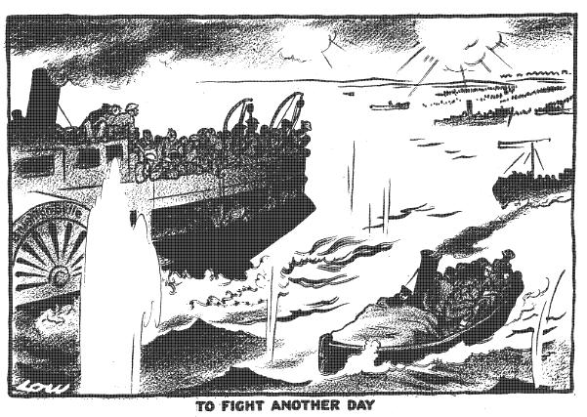  Source B  This David Low cartoon appeared in the Evening Standard on 8 June 1940.  The reality, of course, was that Dunkirk was a monumental defeat. Historians have called the image of the evacuation which grew up in Britain ‘the necessary myth’ – necessary to maintain morale, but not true. When the navy tried to take the troops from the beaches, the boats became stuck on the mud, so the idea was abandoned – most soldiers were evacuated, not from the beaches, but by ferry from Dunkirk. Small craft only became involved after 31 May, and only evacuated 25,000 men (a tiny proportion). Although many men behaved with perfect discipline, there were examples of indiscipline – some troops stole food from local people, and there were stories of officers deserting their men to be evacuated first. And the evacuated French hated England so much that many chose to return to France to be sent to prison camps.  In private, Churchill called Dunkirk ‘the greatest military defeat for many centuries’.  Source D  In a bank at Accrington. Lancashire, one frightened local businessman arrived to draw his money out, asking in a panic, ‘What shall we do when the Germans get here?’ The deputy-manager answered him: ‘Do? I’ll tell you what we’ll do. We’ll get a gun and we’ll shoot the buggers!’ Here surely spoke the authentic accents of Britain in 1940.  Norman Longmate, How We Lived Then (1971)  Tasks  3. What can an historian learn from Sources B–E about the attitude of the British people in 1940.  4. Is there enough evidence in Sources B–E to say that the British faced the disaster of Dunkirk bravely?  5. Look at your answers to Task 2. Do you agree with the interpretation of Dunkirk in Source A? Use Source A and your own knowledge to explain your answer. | Did You Know?  Chamberlain resigned, and, on 10 May 1940, Winston Churchill took over as Prime Minister. ‘I have nothing to offer you but blood, toil, tears and sweat… victory, however long and hard the road may be’, he told the British people on 13 May.  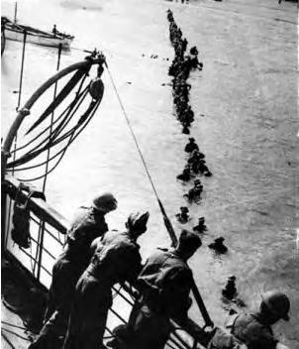  Newspaper and newsreels were full of pictures such as this one, which shows troops wading out to a troop ship close into the shore.  Tasks  1. Make a list of all the upbeat words and phrases.  2. Use only Source A to answer:  - How did the British treat the French?  - Who was to blame for the military setback?  - How did the soldiers behave during evacuation?  - How were the men brought home?  - Where were the men picked up from?  - Was Dunkirk a defeat or a victory?  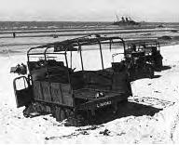  The reality of Dunkirk: vehicles abandoned to the Nazis. The British army left behind 2,500 guns, 84,500 vehicles, 77,000 tons of ammunition, 416,000 tons of supplies and 165,000 tons of petrol. 68,000 soldiers were killed or taken prisoner.  Source C  Far worse than death would be for the children to grow up Nazis, so if they land I must be prepared to shoot the children and myself.  A Cornish mother  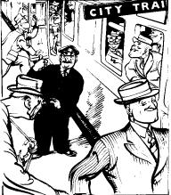  Source E  This Lee cartoon of 21 May 1940 in the Evening Standard’s ‘Smiling Through’ series is entitled: ‘Ups and Downs’. The train guard is shouting to one depressed-looking man: "No, Sir, only 'Confident Smilers' this end, Sir. 'All is lost Brigade' right at the back."

The Battle of Britain  The Battle of France is over. The Battle of Britain is about to begin. Upon this battle depends the survival of Christian civilization… Hitler knows that he will have to break us in this island or lose the war… Let us therefore brace ourselves to our duties, and so bear ourselves that, if the British Commonwealth and Empire lasts a thousand years, men will still say, This was their finest hour.  Winston Churchill, speaking in the House of Common (11 June 1940 ).  Hitler wanted to invade Britain. He called his plan ‘Operation Sealion’. He had detailed plans of who would rule Britain after it was conquered. His propaganda machine had already made a newsreel of the ‘victorious’ German soldiers and the British they had ‘captured’.  But Britain was defended by the Royal Navy, which was much stronger than the German Navy. If Hitler was going to mount an invasion of Britain, he would have to find a way to defend his invasion barges from attack. The German airforce – the Luftwaffe – could defend the invasion, but, to do that, Hitler would first have to knock out the Royal Air Force (RAF). That is how the Battle of Britain came about. The Battle of Britain was really the first part of Hitler’s invasion of Britain.  Four developments laid the foundations of Britain’s survival.  - Firstly, Britain had built a series of radar stations (July 1935). British radar was superior because, not only could it tell where the enemy planes were coming from, but it had a way to telling the fighters so that they could go and attack them.  - Secondly, in July 1937, Air Chief Marshall Dowding was appointed Commander-in-Chief of Fighter Command. He was a brilliant commander who – on a small budget – was able to reorganise the RAF into four Groups, each divided into a number of sectors (each with a main sector airfield with a number of supporting airfields).  - Thirdly, the British developed two brilliant planes – the Hurricane (Nov 1935) which was reliable and was used to shoot down the Luftwaffe bombers; and the Spitfire (March 1936), the fastest plane in the world, which was used to destroy the Nazi fighters which protected the bombers.  - Fourthly, in May 1940, Churchill put Lord Beaverbrook (owner of the Daily Express) in charge of aircraft production. He ran one appeal for aluminium – ‘We will turn your pots and pans into Spitfires and Hurricanes’ – and another scheme where towns, groups or individuals could ‘buy’ a Spitfire (for £5000) and send it off the fight the Nazis. He also set up a Civilian Repair Organisation, which made new planes from the left-over pieces of planes which had been shot down. Beaverbrook cut through government red tape, and increased the production by 250%; in 1940, British factories produced 4,283 fighters, compared to Germany’s 3,000.  The Battle of Britain  The Battle of Britain started officially on 10 June 1940, when the Luftwaffe attacked a convoy of ships off Dover. But the real air war started on 12 August (when the Luftwaffe attacked the RAF), and lasted until 31 October.  At first the Luftwaffe attacked radar stations and airfields. Although the Luftwaffe lost more planes than the RAF, by the 31 August the RAF was at its last gasp – in the previous fortnight the RAF had lost 295 planes destroyed and 170 damaged, 103 pilots killed and 128 wounded. Flying five or more ‘sorties’ a day, the young British fighter pilots (nicknamed ‘Dowding’s chicks’) were becoming exhausted; more importantly, the RAF was not training new pilots as fast the pilots were being killed. The weekend 30-31 August was the worst weekend of the battle for the RAF, with 65 fighters destroyed and 6 of the seven sector stations in the vital south-east Group out of action.  Just as Fighter Command was about to collapse, however, a miracle happened. On 24 August, by accident, some Luftwaffe bombers had dropped their bombs on London. The next few nights, the RAF replied by bombing Berlin. Hitler was angry. On 2 September he ordered his bombers to attack London. On 7 September the Nazi bombing raid was so huge that a false alarm went round the south-east of England: code-word ‘Cromwell’ – invasion imminent. Church bells rang and the Home Guard mobilised. It was not known at the time but one section of coast identified by the Nazis as a landing ground was defended by a Home Guard platoon with just one machine-gun!  Hitler’s decision to stop attacking the RAF gave it time to recover. On 15 September, the Luftwaffe came by day in huge numbers. It expected to sweep the RAF from the skies. But the RAF fought them off. At one point every British plane was in the sky – soon, some would have to come in to refuel and there were no reserves to protect them. But the Luftwaffe, too, was at the limit and – just in time – it turned back.  15 September is celebrated as ‘Battle of Britain day’.  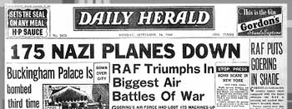  Headline from 16 Sept. In fact, only about 69 enemy planes were destroyed. Does this mean that this newspaper is a useless source to historians?  In the meantime, the RAF had been bombing the Nazi invasion fleet. On 17 September, Hitler ordered the postponement of Operation Sealion. Instead, the Luftwaffe concentrated on night-bombing London (the ‘blitz’).  In all, the RAF lost 1,173 planes and 510 pilots and gunners killed in the Battle of Britain. The Luftwaffe lost 1,733 planes and 3,368 airmen killed or captured. If the Luftwaffe had succeeded, Britain would have been invaded and conquered. But the RAF held out, and Britain survived. |  | 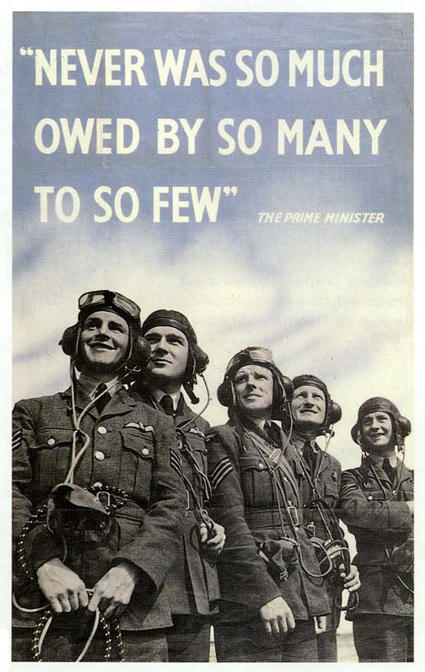  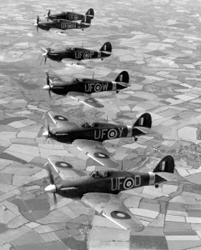  Hurricanes of 601 squadron  Did You Know?  Dowding, a Scot was a dull, boring character nicknamed ‘Stuffy’  Did You Know?  The Spitfire was designed by Reginald Mitchell, who was dying of tuberculosis. He worked round the clock on the plane, and finished it just before his death.  Source A  The gratitude of every home… goes out to the British airmen who, undaunted by odds, unwearied in their constant challenge and mortal danger, are turning the tide of world war by their prowess and by their devotion. Never in the field of human conflict was so much owed by so many to so few.  Winston Churchill, in the House of Commons, 20 August 1940  Explanation: ‘Never in the field of human conflict [=war] was so much [=freedom] owed by so many [=the people of Britain] to so few [the pilots of the RAF]’.  Tasks  1. Construct a timeline of the Battle of Britain, including the following dates, with a short description for each:  - July 1935  - Nov 1935  - March 1936  - July 1937  - May 1940  - 10 June 1940  - 12 August 1940  - 24 August 1940  - 31 August 1940  - 2 September 1940  - 7 September 1940  - 15 September 1940  - 17 September 1940  - 31 October 1940  2. Study Source A. Find the four qualities of British airmen which helped them to win the battle.  3. Churchill praised the pilots for winning the Battle of Britain. Do you agree? Can you find SIX other reasons why Hitler failed to invade Britain?
The Blitz  Hitler expects to terrorise and cow the people of this mighty city… Little does he know the spirit of the British nation, or the tough fibre of the Londoners.  Winston Churchill, broadcast 11 September 1940.  All reports from London are agreed that the population is seized by fear… The Londoners have completely lost their self-control.  Nazi-controlled French radio, 18 September 1940  The city was in darkness  Thick black-out material (at 2 shillings a yard) prevented any gleam of light from the windows. At the start of the Blitz people feared even to strike a match. Many things (including pavement edges) were painted white; pedestrians ‘wore something white at night’. They lost their way, walked into canals, bumped into lampposts. Car headlights were hooded. It was said that more people died from traffic accidents than from Nazi bombs. Only criminals, lovers and astronomers loved the Blackout. Fire-watchers and street wardens stayed awake all night listening for any attack. Things were not always as well-organised as they might be; my mother was put on listening duty, even though she was deaf.  The sirens sounded.  Some mothers grabbed their children and went out to the Anderson shelter in the garden – brightened up with flowers growing on the roof, and pictures, even wallpaper, on the walls. They took with them birth certificates, Post Office books, First Aid kit and personal treasures. Others preferred to shelter under the Morrison shelter in the sitting room, or in the cupboard under the stairs. In the City, thousands were sleeping the night in the Underground, or in fouling-smelling public shelters. In places such as Coventry and Plymouth, many people had left the city and gone to sleep outside in the surrounding countryside.  Then came the throb of plane engines. People could tell the different enemy planes by their engines, as they could tell them by their shapes. The engines seemed to be saying: ‘Where are you? Where are you?’ Anti-aircraft (‘ack-ack’) guns opened fire – people were killed by their shells falling back to earth.  Down came the bombs.  High explosives (HEs) blew up buildings. Incendiaries caused fires and were dropped in clusters called ‘breadbaskets’ or ‘Molotovs’. Later in the war, the Nazis dropped parachute bombs – which exploded when they touched the earth. Unable to see where the factories were, the bombers resorted to ‘carpet- bombing’. 90% of houses in London were damaged. On the night of 14-15 November 1940 Coventry was so badly bombed that the Nazis coined a new word: ‘coventrate’ – meaning to destroy a whole city. Winston Churchill visited Coventry. ‘They have sown the wind, they shall reap the whirlwind’, he said. Later in the war he sent 1,000-bomber raids to attack German cities. Many German civilians were killed; some people nowadays say Churchill was wrong, but during the war many British people thought it served them right.  Not everybody sheltered during a raid. Firemen fought the fires. Fire-watchers tried to put out incendiaries. Rescue workers dug for buried people.  Next day  Those who could tried to get on with their lives. The homeless went to government rest centres. The Women’s Voluntary Service provided cups of tea and blankets. Bomb disposal men tried to disarm UXBs (unexploded bombs). It was a dangerous job; many UXBs were booby-trapped.  Not everybody behaved bravely. Some people talked about surrendering. In the East End of London, there was some looting. The government’s Mass Observation researchers were worried. | Source A  It has started! If they keep this up for another week, the war will be over. The East End won’t be able to stand much more of this sort of thing. What’s more, the Fire Brigade won’t be able to stand much more of it either. This is the first leave I’ve had since Thursday…  Down came the bombs. You could hear the HEs going over the top with a low whistling sound. After a moment or two they started in with the incendiaries and dropped a Molotov over the docks. There was fire in every direction. The City was turned into an enormous, loosely-stacked furnace, belching black smoke.  London Air Raid Warden, speaking in January 1941.  Source B  The British nation is stirred and moved as it never has been at any time in its long and famous history, and they mean to conquer or to die. What a triumph the life of these battered cities is over the worst that fire and bomb can do!  The terrible experiences and emotions of the battlefield are now shared by the entire population. Old men, little children, the crippled, the veterans of former wars, aged women, the hard-pressed citizen, the sturdy workman with his hammer in the shipyard, the members of every kind of ARP service, are proud to feel that they stand in the line together with our fighting men. This, indeed, is a grand, heroic period of our history, and the light of glory shines upon all.  Winston Churchill, broadcast 27 April 1941.  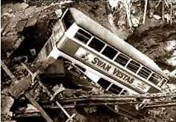  Source C  14 October 1940: a bomb killed 64 people sheltering in an Underground station.  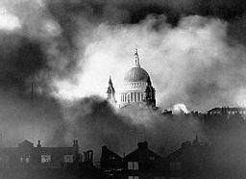  Source D  This picture – showing St Paul’s towering over the fires of the Blitz – has been called ‘the Greatest Picture of the War’. It had symbolic meaning to the people at the time. The government allowed this photo to be published. Can you explain why?  Source E  I just went down to the Post an’ when I came back my street was as flat as this ‘ere wharfside – there was just my ‘ouse like – well, part of my ‘ouse. My missus was just making me a cup of tea for when I came ‘ome. She were in the passage between the kitchen and the wash-‘ouse, where it blowed ‘er. She were burnt right up to ‘er waist. ‘Er legs were just two cinders… and ‘er face… The only thing I could recognize ‘er by was one of ‘er boots…  I’d ‘ave lost fifteen ‘omes if I could ‘ave kept my missus.  Hull Air Raid Warden.  Tasks  Use the sources and your own knowledge to answer the following questions:  1. Look at Source A. What can an historian learn from it about how the British people reacted to the Blitz?  2. The government did not allow Source C to be published. Explain why.  3. The government allowed Source D to be published. Explain why.  4. Why are Sources B and E so different?  5. In Source B Churchill claimed that the British people were proud to share the battle with the soldiers. Nazi radio claimed they were seized by fear. Which interpretation do the facts and sources on these pages suggest was closer to the truth?

Conscription  Conscription was reintroduced for young men, with an option of joining the Territorial Forces to get evening and weekend training, and the Territorial Army was doubled. I was affected by this and, being in the middle of exams, elected to join the 6th Battalion Devonshire Regiment T.A. at Barnstaple Drill Hall - a culture shock as a private being mixed in with all sorts and sizes.  Memories of Mr. R B Blatchford MBE, Barnstaple  After Hitler invaded Czechoslovakia the British government began to prepare for war, so in May 1939 the Military Training Act was passed. This said that men aged 20-22 could be called up for 6 months military training. There was just one call-up before war was declared – in June – the first ever conscription in Britain in peacetime. When war was declared 3 September 1939, all men aged between 18 and 40 became legally liable for call-up under the new National Service (Armed Forces) Act. As casualties in the armed forces rose, in 194 1the age limit had to be raised to 51. Certain occupations – such as Tax inspectors, engineers or coal miners – were exempt, on the grounds that they were essential to the war effort at home.  Although conscription had been introduced, many people still did volunteer, particularly for the more glamorous 'teeth arms', such as the air force and submarines. Many others, in exempt occupations, or too old or too young to join the armed forces, volunteered as Air Raid Precautions wardens or for the Local Defence Volunteers (‘Home Guard’).  Neville Chamberlain believed that people should have the right to refuse service on grounds of conscience, and a system of tribunals was set up to which Conscientious Objectors could apply. Nevertheless, the press ran a fierce campaign against them, many employers refused to give them a job, and a total of 60,000 objectors were sent to prison. Many Conscientious Objectors worked on farms, in hospitals or in the Pacifist Service Units amongst the socially deprived. Others risked their lives with the Friends Ambulance Unit on the battlefront.  In May 1940, the Emergency Powers Act gave the government the power to conscript workers into essential industries. The government tried not to use conscription because Ernest Bevin, Minister for Labour, believed that people would work better if they were not forced into work. Nevertheless, the labour shortage became so severe that in March 1941 the Essential Works Order introduced conscription. Under this, women between 20 and 30 became liable for conscription into war work. Women with children under 14 were exempt but many volunteered anyway, encouraged by the introduction of day care nurseries. In 1943, 22,000 ‘Bevin boys’ were conscripted to work in the mines. However Bevin – in order to prevent industrial troubles – was careful to expand welfare facilities, improve working conditions, and ensure ‘fair wages’; developments which eventually resulted in the introduction of the Welfare State after the war.  Source A  One day an envelope marked OHMS fell on the mat. Time for my appendicitis, I thought.  ‘For Christ’s sake don’t open it’, said Uncle, prodding it with a stick. ‘Last time I did, I ended up in Mesopotamia, chased by Turks… Weeks went by, several more OHMS letters arrived, finally arriving at the rate of two a day stamped URGENT.  ‘The King must think a lot of you son, writing all these letters,’ said Mother as she humped sacks of coal into the cellar. One Sunday, while Mother was repainting the house, as a treat Father opened one of the envelopes. In it was a cunningly worded invitation to partake in World War II, starting at seven and sixpence a week, all found. ‘Just fancy,’ said Mother as she carried Father upstairs for his bath, ‘of all the people in England, they’ve chosen you, it’s a great honour, Son.’  It was now three months since my call-up. To celebrate I hid under the bed dressed as Florence Nightingale. Next morning I received a card asking me to attend a medical at the Yorkshire Grey, Eltham. ‘Son,’ said Father, ‘l think after all you better go, we’re running out of disguises, in any case when they see you, they’re bound to send you home.’ The card said I was to report at 9.30 a.m. Please be prompt.’ I arrived prompt at 9.30 and was seen promptly at 12.15. We were told to strip. This revealed a mass of pale youths with thin, white, hairy legs. A press photographer was stopped by the recruiting Sergeant: ‘For Christ’s sake don’t! If the public saw a photo of this lot they’d pack it in straight away.’  I arrived in the presence of a grey-faced, bald doctor.  ‘How do you feel?’ he said.  ‘All right,’ I said.  ‘Do you feel fit?’  ‘No, I walked here.’  Grinning evilly, he wrote Grade I (One) in blood red ink on my card. ‘No black cap?’ I said. "It’s at the laundry,’ he replied.  The die was cast. It was a proud day for the Milligan family as I was taken from the house. ‘I’m too young to go,’ I screamed as Military Policemen dragged me from my pram, clutching a dummy. At Victoria Station the RTO gave me a travel warrant, a white feather and a picture of Hitler marked ‘This is your enemy’. I searched every compartment, but he wasn’t on the train. At 4.30, June 2nd, 1940, on a summer’s day all mare’s tails and blue sky we arrived at Bexhill-on-Sea, where I got off. It wasn’t easy. The train didn’t stop there.  Spike Milligan, Hitler – My Part in His Downfall (1971).  This comedy extract was not meant to be taken wholly seriously, and Spike Milligan was not the coward he makes himself out to be; can you find the clue in the text which tells us what really delayed him call-up?  OHMS = On His Majesty’s Service. RTO = Regimental Travel Officer | 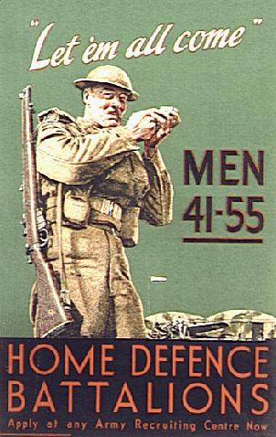  ¼ million men volunteered for the Home Guard on the first day of recruitment. Churchill spoke of ‘a country where every street and every village bristles with resolute, armed men…’ Certainly the men were resolute and – although there were problems with uniforms and weapons – LDV battalions were well-run.  The Home Guard has been idealised by the TV series ‘Dad’s Army’. In fact, working all day then going out at night to drill and train was exhausting for the men.  Did You Know?  Conscription was never introduced in Northern Ireland. The Nationalists there had no desire to serve in the British Army, and the Unionists did not want to see nationalists given military training.  Did You Know?  New Zealand & Australia (1940) and Canada (1942) introduced conscription. French Canadians rioted when they heard about it – in the end, conscripted Canada troops were sent overseas only if they volunteered; men who elected to stay at home were called ‘Zombies’  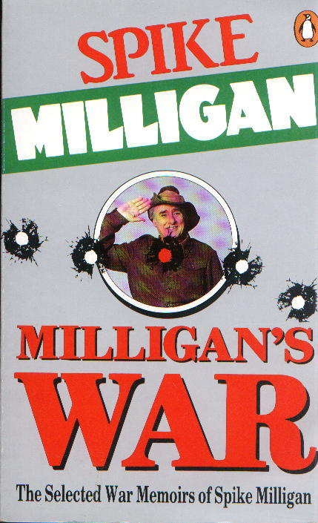  Tasks  1. Write about the following, so as to explain how they affected the lives of the people of Britain:  - Military Training Act  - National Service (Armed Forces) Act  - Emergency Powers Act  - Essential Works Order  2. Study Source A. Try to distinguish between what is a joke, and what is truth.  3. Source A is a comic book written by one of the Goons. Does this mean it is useless for historians?

The Battle of the Atlantic  The only thing that ever frightened me during the war was the U-boat peril.  Winston Churchill  Britain could not produce enough food to feed all its people.  It needed raw materials from abroad to run its industries. If the merchant Navy could not bring these things into Britain by sea, the war would be lost.  The U-Boat Peril  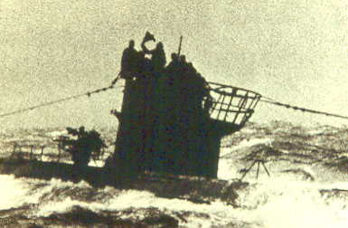  The fall of France allowed U-Boats to operate far into the Atlantic from French ports. Nazi shipyards produced about 20 new U-boats a months, and British merchant shipping losses grew.  After summer 1940, the U-boats attacked in large ‘wolf-packs’ – when a U-boat came across a convoy, it would radio its position to a number of other submarines, which would close in on the convoy. Then they would wait until nightfall and make surface attacks in numbers. On 18 October 1940, a pack of 6 Nazi U-boats attacked slow convoy SC–7, sinking 15 ships in 6 hours. Next day, reinforced by three more U-boats, the pack attacked the 49-ship convoy HX-79, sinking 12 ships in one night.  The Royal Navy did not have enough ships to protect the convoys properly. In November 1940 convoy HX–84 (37 ships escorted only by the armed merchant cruiser HMS Jervis Bay), was attacked by the Nazi battleship Admiral Scheer. Completely outgunned (her shells did not even reach the Nazi ship) the Jervis Bay attacked the Admiral Scheer to give the convoy time to escape – the Jervis Bay and five merchant ships were sunk.  The USA tried to help Britain. In August 1940 the US gave Britain 50 destroyers in exchange for Atlantic naval bases, and, after August 1941, by an agreement called the Atlantic Charter which Roosevelt made with Churchill, convoys were defended by the US Navy. It had little effect. Losses were huge. The worst period was from the beginning of 1942 to March 1943 when 7 million tons of merchant shipping was sunk. In July 1942, 143 ships were sunk in a single month, and in November 1942, 117 ships were lost.  The Tide Turns  Eight things helped the Allies to stop the U-boat menace.  - The work of the British codebreakers at Bletchley Park in deciphering the German Enigma code was vital in giving the Allied navies the edge in the Battle of the Atlantic. In February 1942, however, the German code was improved, resulting in ‘the Drumbeat crisis’ when shipping losses were their greatest – until March 1943, when the German code was again broken.  - Sonar had been invented before World War I, but after 1942 the US Navy Department developed ‘console sonar’ which could plot accurate bearings using an echo ‘ping’. Training of sonar operators was also improved.  - Radar was improved so that U-boats could even be detected in bad weather.  - The British developed HF/DF (‘huff-duff’), whereby U-boats’ positions could be worked out from their radio transmissions.  - Six aircraft carriers were sent to patrol the Atlantic, and this extended air cover to the whole route convoys took.  - Air depth-bombs were developed so that planes could attack U-boats under the water.  - Weapons called Hedgehog and Squid were developed which allowed attack ships to catapult depth-charges up to 300 yards in front of the ship.  - The Allies set up hunter-killer groups of ships, including one aircraft carrier with a number of destroyer escorts, to hunt down and sink U-boats.  The turning point was slow Convoy ONS–5 (April–May 1943), when a convoy of 43 merchantmen escorted by 2 destroyers and a frigate was attacked by a wolf-pack of 30 U-boats. Although 13 merchant ships were sunk, the U-Boats were detected by HF/DF, six U-boats were sunk by patrol-boats or Allied aircraft and – despite a storm which scattered the convoy – the merchantmen reached the protection of land-based air cover causing Admiral Dönitz to call off the attack.  It was the end of the U-Boat menace – 37 U-Boats were lost in May 1943, and 34 in July. The RAF was able to intercept and sink many U-boats as they left harbour. The Nazis gave their U-boats better anti-aircraft guns, and invented a device called Snorkel (which allowed U-Boats to refresh their air without surfacing). ‘Bottoming’ tactics allowed U-boats to avoid detection from sonar and radar. However, after May 1943, the U-boats were on the defensive, and Allied shipping losses fell significantly.  Nevertheless, it must be questioned whether the Allies ‘won’ the Battle of the Atlantic – between 1939 and 1945, 2,753 Allied ships were sunk (gross tonnage 14.5 million) at a cost of 783 Nazi U-boats.  Tasks  1. Make notes on ‘The Battle of the Atlantic’.  2. Does it matter that Source A is by a U-boat commander? | 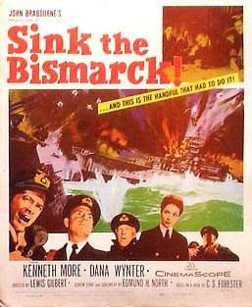  Surface raiders  Powerful Nazi ships such as the Graf Spee, Bismarck and Scharnhorst hunted and sank British shipping. However, the Royal Navy hunted down these ships and sank them (the story of the sinking of the Bismarck (May 1941) was made into an exciting film).  After the sinking of the Bismarck the Nazi navy was essentially pinned in harbour by the Royal Navy and the RAF.  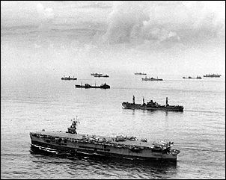  Merchant ships sailed in ‘convoys’ for safety, accompanied by warships. In addition, ‘wide dispersal routing’ (sending convoys by different routes) made them harder for the U-boats to find. This picture shows the USS Santee escorting an Allied Convoy in the Central Atlantic, June 1943  Did You Know?  Convoys to Russia – e.g. PQ–17 (24 ships sunk out of 35) and PQ–18 (10 ships sunk out of 39) – were particularly dangerous.  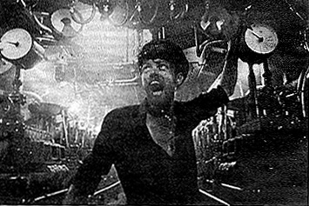  The German film Das Boot (1981) is a bitter account of what it was like to be on a Nazi U-boat  Did You Know?  In May 1931 the British captured the U-100, including an Enigma machine, which helped Bletchley Park to decipher the Enigma code. Again, in October 1942, the British captured the U-559 in the Mediterranean with a code book that helped the British to break the new Nazi ‘Triton’ cipher. The modern film U-571 is based on these events, but ascribes the capture to a small group of Americans!  Source A  It’s a bit difficult for us now, trying to gain an insight into what was going on in the Battle of the Atlantic… During the war the role of the U-boat sailor was a much-despised one. They were thought of as pirates and that sort of thing, but when we talk to people on both sides now, it’s almost as if they were talking about a football match; everything’s jolly and very friendly. It’s hard to realize that all those years ago these same people were at sea trying to kill each other.  Otto Kretchner, commander of U-99, speaking in 1994.

D-Day  Jerry was fighting hard, but soon the beach was swarming with our chaps.  A British infantryman, speaking in 1944.  By 1944, the Allies (Britain, Canada and the USA) were ready to dislodge Hitler from ‘Fortress Europe’. This involved a (very dangerous) invasion of the mainland. The invasion was codenamed ‘Operation Overlord’ and was led by the American General Ike Eisenhower. The invasion day (D-Day) was set for some time in June – the actual date to be decided by Eisenhower at the last minute.  Preparations  It was decided not to try to invade at Calais (where Nazi fortifications were strongest), but in Normandy. So that the invasion forces would know every detail of the landing sites, immensely careful research was done from:  - Low-level aerial reconnaissance photos  - French holiday guide books  - The BBC asked for holiday photos (10 million were sent)  - Sailing books  - French spies  - Col Sam Bassett landed secretly at night to test that the sand was hard enough to bear the weight of tanks.  Other preparations included:  - Huge forces were gathered all over the south of England. Some were sent even to Dover (they were provided with wooden models of tanks) – they were called ‘Patton’s First Army’ (after an American general) to make the Nazis think that the invasion was planned for Calais.  - Thousands of Americans were posted to Britain (people complained that they were ‘overpaid, oversexed and over here’) – some of them eventually married British girls.  - Months of training, practising attacking copies of the Nazi emplacements. These were so realistic that many men were killed in these exercises  - Building ‘mulberries’ – floating harbours that could be towed across the Channel and set up once a bridgehead had been established  - A series of specialist machines were built (e.g. ‘crab’ tanks to clear mines/ bridge-carrying tanks) – they were nicknamed ‘Hobart’s funnies’ after the man who designed them all.  - A Spanish double agent convinced the Nazis that the main invasion was going to take place at Calais, and that the Normandy attack was just a diversion.  - There was one panic when 12 copies of the D-Day plans blew out of the window into the street!  The invasion force was fully ready by 1 June – but the invasion was delayed because of bad weather. In one of their first important roles ever, weather forecasters predicted that the weather would clear on 6 June. Eisenhower ordered the attack.  D-Day  At 3 am on 6 June 1944, a huge armada of 6,000 ships – including 864 converted merchant ships and 4126 landing craft – set sail for Normandy in 47 convoys. They carried 200,000 seamen, 185,000 soldiers and 20,000 vehicles. The weather was still fairly bad. Many of the soldiers were so seasick that they joked that they would not mind going into battle, just to get off the ships!  A few Royal Navy ships raced back and forth between Dover and Calais to make Nazi radar operators think that the invasion was going to take place at Calais.  20,000 men were dropped by parachute or landed in gliders behind enemy lines to disrupt communications and seize key points. The invasion was supported by 11,000 planes, which attacked the Nazis from the air.  7 battleships, 23 cruisers and 105 destroyers laid down a massive bombardment of the Nazi shore defences.  Then the infantry went ashore.  The British and Canadian soldiers landed on three beaches – Gold, Juno and Sword. They experienced heavy casualties (over 4,500) but by nightfall had captured a large area of coastline.  The Americans were less successful. At Utah beach they landed by accident at the wrong place but – by chance – found little Nazi resistance there and captured the beach with only 210 casualties.  At Omaha beach, things were much worse:  - In the morning fog, the B17 bombers had overshot the Nazi defences by 5 kilometres, and most of the naval bombardment fell short, so the Nazi defences (dug into the cliffs) were still very strong.  - Instead of just 800 men of the weak 716th Division, the Nazis had just moved in their crack 352nd Division.  - As the Americans were landing, the powerful tide swept many men and vehicles back out to sea and 10 landing craft sank.  - The Americans did not have any of Hobart’s funnies  Within ten minutes of landing every officer and sergeant of the 116th Regiment was dead or wounded, and the Americans sustained 3,000 casualties in first few hours. By 10 am, only 300 men had managed to struggle ashore safely, and by nightfall the Americans still only had ‘a toehold’ on the beach.  On to Victory  Even so, by the end of D-Day, 132,715 men were ashore, and this rose quickly over the next few days – by 12 June 2 million men were in Normandy.  The Nazis fought desperately, but by this time Germany was at the end of her strength, and many Nazis soldiers were just 16-year-olds. By August Paris had fallen and (despite a short Nazi counter-attack called ‘The Battle of the Bulge’) the Allies pushed relentlessly into Germany until they met up with Russian forces advancing from the east (23 April 1945).  On 7 May, 1945, the Nazis surrendered – it was VE Day (Victory in Europe)! | 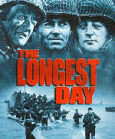  The 1961 film the Longest Day was an historically accurate account of the fighting on D-Day. In it, the American actor John Wayne wins the war.  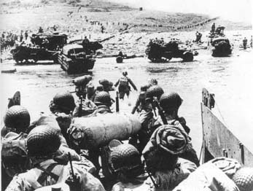  Allied troops go ashore from a landing craft, 6 June 1944. Comparing this picture with the film Saving Private Ryan will help you to appreciate what D-Day was like for the soldiers.  Source A  I’m sick of this ‘John Wayne won the war’ message in Hollywood films. The Americans on Omaha were heroes and I owe them my freedom, but I have yet to be persuaded that they were any braver (or that their objective was any harder) than the British or Canadians – they just didn’t do as well.  Said by a modern historian (2002).  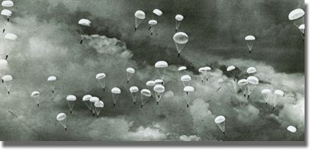  Allied paratroopers are dropped behind enemy lines, 6 June 1944.  Source B  I took a look toward the shore and my heart took a dive. I couldn't believe how peaceful and how untouched, the scene was. The land was green. All the buildings and houses were intact. 'Where', I yelled to no one in particular, 'is the damned Air Corps?’.  Captain Walker, an American, remembering 1944.  Source C  It was wonderful. There they were, marching in to die, just as if they were going to a ball game… The Germans had hidden themselves in cliffs facing the beach and were pouring deadly mortar fire down upon the advancing Americans… They did not have any cover except bomb-made mounds, but they pushed forward, with men falling every way you could look. It was heart-breaking….  British Air Navigator, speaking of D-Day.  Tasks  1. Make notes on ‘D-Day’  2. Do you agree with the author of Source A?

