Put the title Feelings 4 – More Evidence into your exercise book.

Study the information on the webpage, then:

Task One
1. Reading and discussing the sources as a whole class or in a large group.
Write up your findings (see below for some suggested answers) as a table, thus:
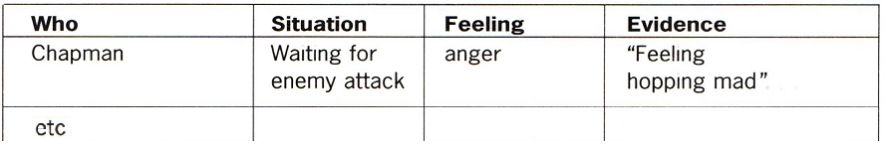

Task Two - Assignment
1. Analyse the list of feelings you have assembled. One way to do this is to compile your list into groups of related feelings – for instance:
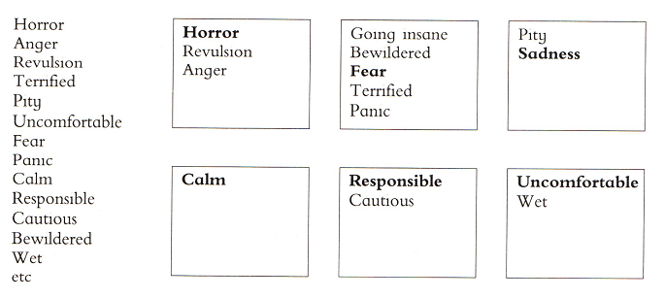

2. When you have done this, you are ready to write your essay: “Describe the thoughts and feelings of a soldier on the Western Front in World War One.’
a. Take a paragraph for each of your groups of feelings.
b. Remember to ‘PEE every paragraph’:
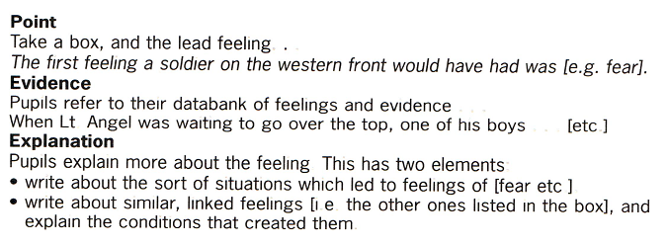
c. Write in the third person future past tense – “he would have…”.
d. Write as a psychologist, analysing and explaining the different feelings of the men.

Here are some answers from my work with my on pupils:

