Put the title Feelings 1 – A Raid into your exercise book.

Study the information on the webpage, then:

Task One
1. Read the story out loud; it should makes difficult listening (as the film All Quiet on the Western Front is difficult to watch).
2. This story a typical of a First World War attack. Working alone or with a partner, study the story to work out the sequence of events in the raid/ an attack.
3. Design an illustrated flow-chart to show ‘A Typical WWI Attack’; discuss with a partner how far your flow-diagram falls short of conveying the horrific reality of the fighting.

Task Two
1. Harrison is very open about how he was *feeling* during the events of his story (e.g. “I am calm”), but it is also possible to deduce many more feelings (e.g. revulsion/ pity). Working in small groups, but then sharing your suggestions in a whole-class plenary, make a list of all the feelings that Harrison experienced during the raid.
Write up your findings as a table, thus:
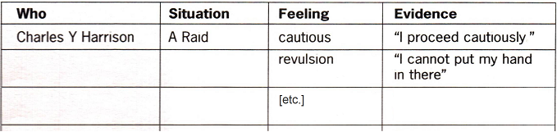
(You will be adding to this over the next few lessons.)

POSSIBLE SEQUENCE OF EVENTS FROM THE STORY:
Here is a list that I would draw up with my students after they had done the exercise in Task 1.2:

