Put the title Mining Coal into your exercise book.

Note that these tasks cover two webpages – the webpage on Mining Coal, and the webpage on Developments at the Pit-head.

Study the information on the webpage, then:

Task One – using the webpage on Mining Coal
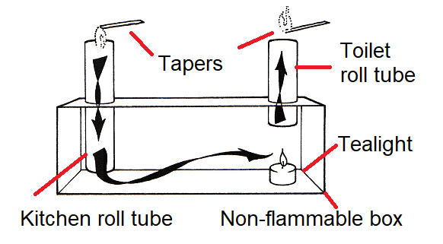
1. Construct and do this experiment – or, if you cannot, at least explain the principle from the diagram – how an upcast shaft drew flammable gases out of the mine:
2. Working as a whole class, discuss and understand how a 19th Century mine worked, especially the function of the wind vane, the stoppings and the trapdoors.
3. Using worksheet EC2 below:
- Remembering that fresh air was pulled down the downcast, through the mine and, finally, up the upcast, locate the downcast and upcast shafts on the plan. In one colour, starting at the downcast, draw the direction of the airflow along the boards (ie draw a thick line along the tunnels, it cannot cross a black stopping). Use your diagram to explain to a partner how the air was forced to weave in and out through the mine. Mark the colour of your line on the key at the top-right of sheet.
- The stoppings in the top left corner of the plan have been omitted. Using your understanding of the principle of how a mine was ventilated, add stoppings to make the air weave through the tunnels in such a way as to ventilate all of them.
- Can you see that there was a section of the mine at the working face that was not properly ventilated? (This is where the explosion happened in 1812.) Denote this on the plan by shading in the correct area, then mark the colour of your shading on the key.
- Tubs full of coal had to travel from the working face, and then leave the mine via the downcast shaft. Note the trap doors denoted by a double line (thus: ‘=’). Draw on your plan a second line from the working face to the downcast shaft to show the way out for the corves (ie the tubs of coal)? Mark the colour of this line on the key.
4. Using the links on the webpage, perhaps including google research of your own, write on your own the story of the Felling Explosion of 1812. Try to make it as sad and gripping as my description of the Stanley pit disaster.

Task Two – using both webpages
1. Write on your own a description of how coal mines changed between 1770 and 1844.
2. Share what you have written with a partner. Discuss how true is the statement: ‘there were no great inventions which revolutionised the production of coal’.

