Put the title Foul Factories? into your exercise book.

Note that these tasks cover two webpages – the traditional webpage on Foul Factories, and the revisionist Factory Conditions – Challenged, which allows you to question the traditional view.

Study the information on the webpage, then:

Task One – using the webpage Foul Factories:
1. Read the Introduction. Working alone, find THREE reasons businessmen built factories; which of these was most likely to affect the conditions in which they made their employees work?
2. From Source 1, compile a list of all the bad conditions in a 19th century factory it mentions.
3. Study sources 2-9. Some of them will provide evidence which supports Peter Moss’s account in Source 1 – you may find some more bad conditions to add to your list.
4. Build a simple table of two columns to list your findings, with proving-evidence, thus:
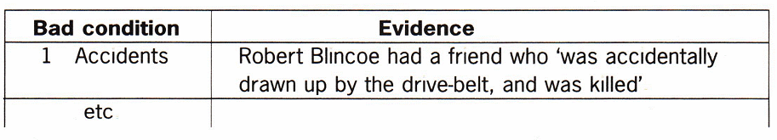

Task Two – using the webpage Factory Conditions – Challenged:
1. Read the Introduction. Discuss with a partner whom you instinctively believe: Sadler, or Morpeth & Gisborne?
2. Working in a small group, read and consider Source 1:
- How many hours a day did the girls spend working?
- How much rest were they allowed during the day? How much sleep did they get?
- Compare these figures with your own experience of children aged 8-12.
- Study Coulson’s last answer, especially the words he uses – what was he doing here and why?
- Did Coulson have a motive to exaggerate? Do you believe him?
3. Working again with your group, read and consider Source 2:
- Did Sharp and the Penny Magazine reporter have any motive to exaggerate? To what extent do you believe their description of the factory?
- Does the information in Source 2 prove that all factories were kind and well-run?
- How long did Wood make them work?
4. Source 3-5 provide an excellent example of how motive can influence presentation:
- Which Source presents the most pleasant picture of factory life? Study the picture and the caption and suggest why it presented such a positive image of the British cotton industry.
- Which Source presents the most brutal picture of factory life? Suggest why.
- Which Source is the saddest? Suggest why.
- Do you think the artists of Sources 4 and 5 had ever been in a cotton mill? Explain why.
5. Working as a whole class, discuss:
- Which of the pictures in Sources 3-5 do you think best illustrates the truth about factory life in the 19th century? Have you ANY reliable proving-evidence for our opinion?
- How much has the information on this webpage has changed the impression you gained from your work on Foul Factories? Can we ever know what work in the factories was like?

