Put the title Changes in Eldon into your exercise book.

Study the information on the webpage, then:

Task One:
1. Play the ‘Spot the Difference’ game using worksheet D6.
2. Working with a partner or in a small group, make a list of all the differences you can find between the maps of Eldon in 1857 and 1897.
What has disappeared? What has changed? What has appeared?
3. Working as a whole class, share your findings, suggesting for each WHY the growing population led to that change.
4. Write up your findings, following the pattern:
“They ... [ details of change] …, because … [explanation of cause] …
(where the more thorough the explanation, the better the work.)

Task Two:
1. Working with a partner or in a small group, make a list of all the ways you can think of that a growth of population might have stimulated a growth in agriculture or industry.
When you have finished, if you, wish, study the textbook quotes on the Effects of the Demographic Revolution on the Industrial Revolution and search for ideas to add to your list.

ANSWER TO THE ‘SPOT THE DIFFERENCE’ TASK
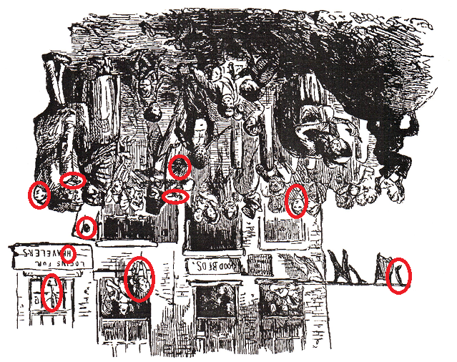
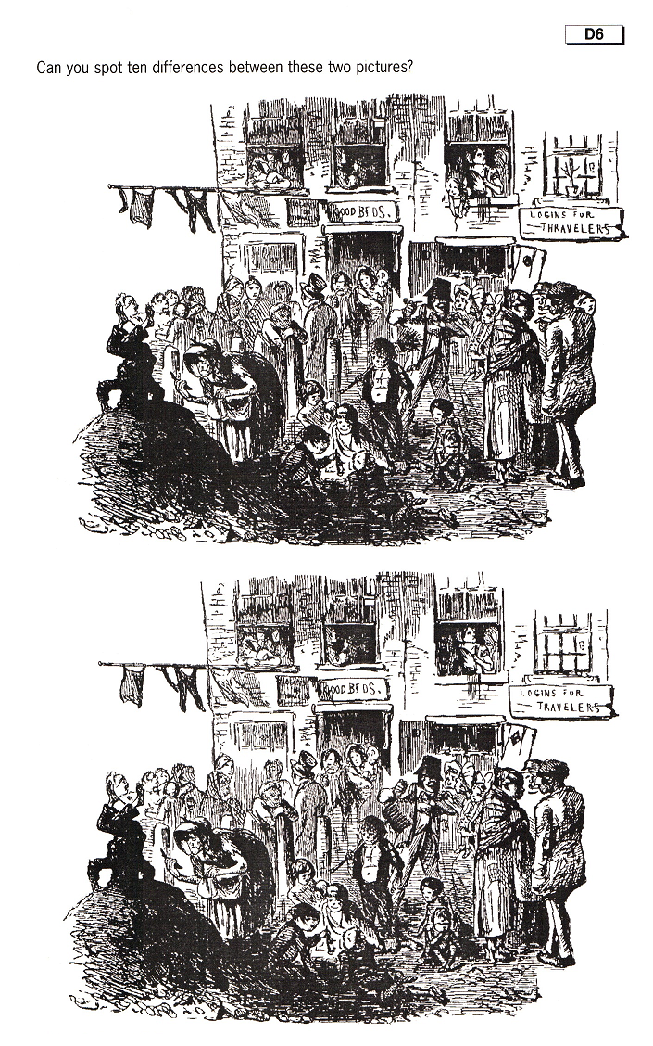
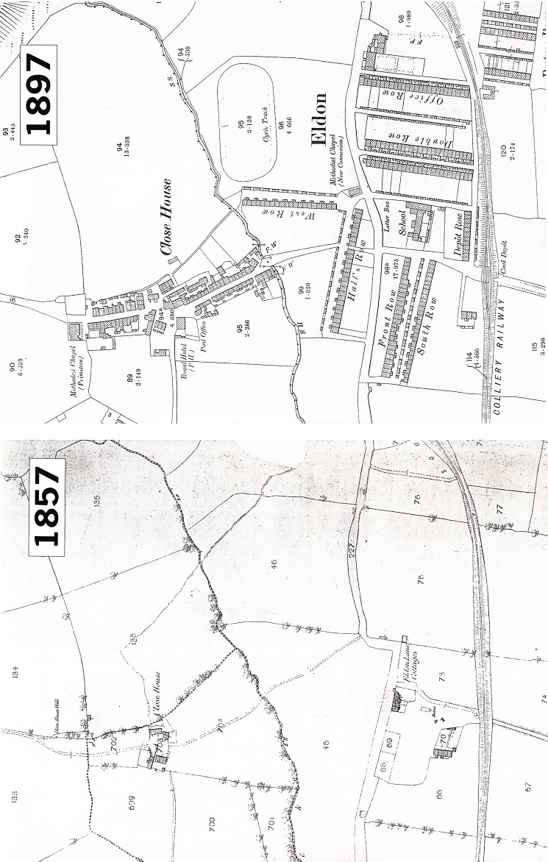
Effects of the Demographic Revolution on the Industrial Revolution – a collection of textbook quotes.

1 JA Hobson, The Evolution of Modern Capitalism, 1894
The existence of large, accessible markets with populations willing and economically able to consume the products of capitalist industry [is essential for industrial development].

2 EW Gilboy, Demand as a Factor in the Industrial Revolution, 1932
Without populations willing and able to consume industrial products on a large scale, the type of business made widespread by the Industrial Revolution cannot exist.

3 Phyllis Deane, The First Industrial Revolution, 1965
It is clear that there was a complex two-way relationship of cause and effect shaping these two trends – population on the one hand and output on the other – even if it is not clear exactly what form that relationship took at all times...
It seems reasonable to suppose that without the growth of output dating from the 1740's the associated growth in population would eventually have been checked by a rise in the death rate due to declining standards of living.
It seems equally probable that without the population growth which gathered momentum in the second half of the eighteenth century, the British industrial revolution would have been retarded for lack of labour.
It seems likely that without the rising demand and prices which reflected, amongst other things, the growth of population, there would have been less incentive for British producers to expand and innovate, and hence that some of the dynamism which powered the industrial revolution would have been lost.
It seems equally likely that the expanding employment opportunities created by the industrial revolution encouraged people to marry and to produce families earlier than in the past, and that they increased the average expectation of life.

4 James Clifford, Aspects of Economic Development, 1967
ECONOMIC EFFECTS
What would be the requirements of such an expanding population? Food and clothes are obvious necessities and the growing demand for these provided the necessary incentive for farmers and textile manufacturers to increase production.
In addition to food and clothes, general manufactured household goods were also needed and here was the incentive for the hardware trades to expand… This expansion then brought about changes in the organisation of such branches of the economy (e g. the changes in agriculture from subsistence to capitalistic farming and in industry from the domestic to the factory system, etc.).
In order that such demands could be satisfied … capital goods (buildings, machines, raw materials, iron, etc.) were first necessary. Money had to be obtained to marshal the necessary factors of production…
The increasing demands of changing industry, commerce and agriculture, stimulated a progressive move in transport... Once population had set in motion these initial changes, there was a tendency for them to snowball and for the economic multiplier to begin to work,
SOCIAL EFFECTS
Such great changes in the total volume of population and a simultaneous shift m its distribution, were bound to have a profound effect on living and working conditions – for instance, the growth of new towns with their harsh social environment; the abominable conditions of the new factories, mines and foundries.
Changes such as these were bound to give rise to a multitude of social problems, many of which had never existed before…

5 Simon Mason, Work Out Social and Economic History GCSE, 1988
The growth of population between 1700 and 1900 may have helped the growth of Britain's economy. There were more people to work in factories and on farms and there were more people with money to spend on consumer goods (e g. food and clothing). The notes below show how population growth may have affected the economy
(a) Farming
There were more people to feed. More money was invested in farming so that farmers could grow more wheat and vegetables and rear more cattle. Without extra food there could not have been extra people. The Increased demand for food encouraged farmers to develop new agricultural methods
(b) Industry
The growth in population meant a growing demand for goods such as coal, textiles and ironmongery. These industries expanded and flourished to meet this demand. However, in some industries an increase in the number of workers available may have slowed down the rate of technological change. There is little point in introducing labour-saving machines in factories if labour is cheap.
Some historians have argued that industrial changes were a cause of population increase and not the result of it.

6 Ben Walsh, British Social and Economic History, 1997
Why was a rising population a good thing for industry?
It increased demand
More people needed more food, so laming had to change and adapt to meet the demand.
They needed more cloth, winch stimulated change in the textile industries.
They needed more cooking pots and more tools which stimulated the iron industry….
They needed more coal to heat their homes, which stimulated the mining and the transport industries…

It also provided workers
The population in both towns and countryside was increasing. Very soon most villages had more adults than there were jobs. The surplus young adults became miners to mine the coal, spinners and weavers to make cloth, puddlers to make iron, builders to build houses and labourers to cut canals and lay the railways. They swelled the industrial cities which grew at a phenomenal rate, particularly in the mid-nineteenth century.
Clearly, Britain's industrialisation was closely linked to its rising population.

7 Joel Mokyr, The British Industrial Revolution, 1999
Population, of course, began to increase rapidly after 1750, but this was a worldwide phenomenon and it seems far-fetched to link it directly to the Industrial Revolution.
In a technologically-static world, population growth would have led to declining living standards [and] to sharply higher agricultural prices, hardly a stimulus for industrial demand.

