Put the title Africa in your exercise book.

Study the information on the webpage, then:

Task One:
1. If you ask adults about their memories of school, some will say they loved it, others will say they hated it. In a small group discuss why their perceptions might be so different. It is possible for anyone to come away from school with an objective view about it?

Task Two:
1. Divide the class into two halves; working alone or in small groups, half the class looks at Source 1, the rest look at Sources 2-6.
Taking the sources at their face value, what do they tell us that Africa and the Africans were like?
Make sure that BOTH groups realise that they are not learning the truth, but ‘what the sources said’.
Share, listen to, and compare what the other half of the class discovered.
Discuss possible reasons why the two portrayals are so different.
2. Study Sources 7- 9. Do these sources help you to decide which of the two conflicting opinions was more correct? Why?
Consider also the point made by Brue that the Africans’ behaviour was in part caused by centuries of the slave trade. Looking through the complaints made in sources 2-6, suggest which of those characteristics may have been caused by/the result of the slave trade.

Task Three:
1. Working as a whole class, study the provenance information of all nine sources (who wrote it and when). Referring to the reasons you suggested as to why source 1 and sources 2-6 differed so much, evaluate how much you trust each source.
2. Use the worksheet ‘Africa’ to make notes of what each source said about Africa/the Africans, and your thoughts about how reliable/trustworthy each source is (remember that the key thing is to explain why you gave it that score).
3. Discuss as a class whether it is possible AT ALL from contemporary sources to come to any conclusion about what Africa and the Africans were like?

ANSWER TO QUESTION

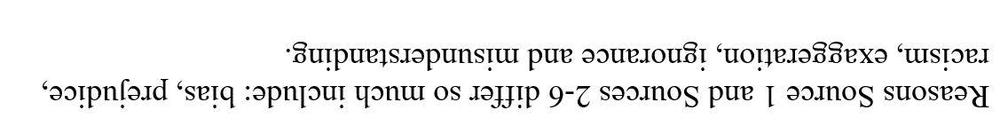


Source | What it says about Africa and the Africans | How much I trust it … and why | Reliability Score/5
1
2
3
4
5
6
7
8
9

