Put the title Choosing A Side in the Civil War in your exercise book.

Read the information on the webpage, then:

Task One
1. Working as a whole class, study Sources 1 and 2.
- Looking at the beliefs of the two protagonists, can you relate them to any of the issues you studied in the last lesson, on the Causes of the Civil War?
2. Turn the beliefs in Sources into statements of decision – e.g. ‘I’m a Cavalier, and I’m fighting for the King because…’.
3. Complete the worksheet ‘A Time to Decide’ as fully as possible given your knowledge at this point.

Task Two:
In reality, the decision whether to fight for king or parliament was rarely so clear-cut. Most people had conflicting feelings and interests, and struggled with their conscience.
1. Working with a partner or in a small group:
- Discuss and do the worksheet ‘Decisions, decisions’
- Discuss and do the worksheet ‘Making your Mind Up’
- Discuss and do the worksheet ‘A Matter of Conscience’

2. Coming together as a whole class, discuss:
- ‘What factors made choosing a side in 1642 so very difficult’?

Task Three:
1. Working in small groups, or as a whole class, cut up the cards on the worksheet ‘Choosing a Side Spectrum’ and arrange them into a spectrum, from the most rabid Cavalier to the fiercest Roundhead. Discuss and explain your choices.

2. Coming together as a whole class, discuss your original answers to the ‘A Time to Decide’ worksheet. What do you think about those answers now?

3. Write a more sophisticated explanation of why people chose the support EITHER the king OR Parliament.

Cavalier  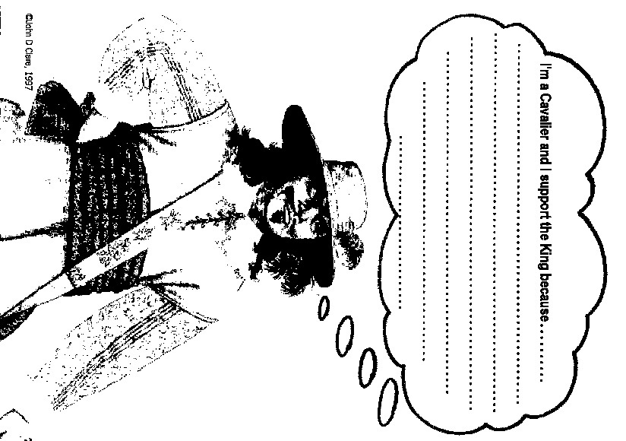 | A Time to Decide…
Roundhead  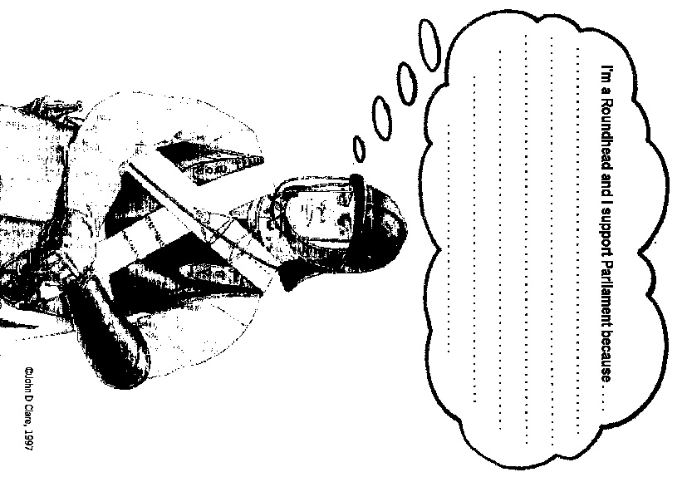 | A Time to Decide…
Decisions, decisions

Look at what each of the people 1-8 below are saying. If you think they would have fought for the king, colour their box in blue. If they would have fought for parliament, colour it red.
People with opinions 9-12 would have found it more difficult to choose. Who do you think they would have decided to support in the end? Colour their box blue or red.
Explain ALL your decisions.

Opinions | Explanation WHY
1. Ship money is wrong. The king shouldn't collect it.
2. The king is king by Divine Right. We ought to obey him.
3. Churches should be plain and I hate the bishops.
4. Churches should be decorated like Archbishop Laud wants.
5. The king gave me a monopoly — I made lots of money!
6. Charles's taxes are wrong. Parliament ought to collect taxes.
7. I'm a Catholic. I liked Laud's reforms.
8. It was wrong of Charles to send Parliament away.
9. I hate bishops —but we ought to obey the king!
10. I believe in the king — but he put me in prison for not paying ship money!
11. I feel I ought to obey the king — but my wife hates Laud's reforms in the Church
12. I support Charles, but my landlord supports Parliament!
Making your Mind Up

Look at each of the people 1-10 below. Who do you think they would have decided to support in the end? Colour their box blue or red.
People 1-3 had quite an easy decision, but the others would have find it very difficult to decide.
Explain ALL your decisions.

People | Explanation WHY
1. A lawyer who is an MP and a Puritan, and has been arrested for refusing to pay ship money.
2. A Catholic noble who thinks that England should have a strong king.
3. A Puritan preacher who had his ears cut off by the Court of the Star Chamber.
4. A Puritan noble who believes that the king is sent by God and MUST be obeyed.
5. A Protestant noble who is one of Charles's ministers, but hates Laud's reforms.
6. A Puritan merchant who recently was given gifts and a monopoly by the king.
7. A Catholic noble who was recently fined for taking some of the royal forest.
8. A merchant who doesn't care about religion, but his wife is a strong Puritan.
9. A Puritan who fought in the king's army and hoped to become a royal favourite.
10. A farmer who supports the Divine Right of Kings, but whose son is fighting for Parliament.
A Matter of Conscience

This worksheet looks at four real people. Looking at what they said, who do you think they chose to support? Explain your answers, and try not to cheat by looking at the answers at the bottom!

Person | Explanation WHY
1. Edmund Ludlow
The nation was forced to take arms in defence of its laws, openly and dishonestly broken by the king.
He had made it the chief business of his reign to take away the rights of the people, raising taxes by different tricks without the agreement of Parliament; encouraging a wrong religion… Knowing that the Parliament was the most likely way to put right what was wrong, he tried to stop them meeting.
I thought it my duty as an Englishman, given my age and my energy, when my father asked me to do so, to serve in the Parliament's army. I thought the justice of the cause I took up so obvious that I could not think that many of the people would be such enemies to themselves as not to help.
Edmund Ludlow, Memoirs (1642). Edmund Ludlow was a young lawyer.
2. Lord Paget
It may seem strange that I, who in the beginning of this Parliament supported with all zeal a reformation of all the wrongs in the Church and country, should now in this time of such great danger, desert the cause…
But when I found a preparation of arms against the king… I rather decided to obey a good conscience than any selfish ideas, and I am now on my way to His Majesty, where I will throw myself down at his feet, and die a loyal subject.
Letter from Lord Paget to Parliament (1642)
3. Sir Edmund Verney
I have eaten the king's bread and served him near thirty years, and will not do so bad a thing as to forsake him; and chose rather to lose my life (which I am sure I shall do) to defend things which are against my conscience; for I tell you freely — I have no respect for bishops.
Letter from Sir Edmund Verney to a friend (1642). Sir Edmund died, aged 52, at the battle of Edgehill in 1642, holding the king's banner.
4. Sir Thomas Knyvett
Oh! Sweete hart, I am now in a great confusion what to doe. Walking this other morning at Westminster, Sir John Potts saluted me with an order of Parliament to take upon me my companye and command againe.
I was surpris'd what to doe, whether to take or to refuse. 'Twas no place to argue, so I tooke it, and asked some time to think about it. I had not receiv'd this many howers, but the King sent me an order point blanck to refuse it...
Poore King, he grows still more in hatred heer every day than other; and no wonder when the worshipp of the King of Kings comes to be superstition and idollatries.
Deer wife, I wish my selfe safe in thy arms every night most cordially, and all the Potts in Christendome shall not keep me from thee long.
A letter from Sir Thomas Knyvett to his wife (18 May 1642)
Choosing a Side Spectrum

Arrange the following into a spectrum, from the most rabid Cavalier to the fiercest Roundhead.

Ship money is wrong. The king shouldn't collect it. | A lawyer who is an MP and a Puritan, and has been arrested for refusing to pay ship money.
The king is king by Divine Right. We ought to obey him. | A Catholic noble who thinks that England should have a strong king.
Churches should be plain and I hate the bishops. | A Puritan preacher who had his ears cut off by the Court of the Star Chamber.
Churches should be decorated like Archbishop Laud wants. | A Puritan noble who believes that the king is sent by God and MUST be obeyed.
The king gave me a monopoly — I made lots of money! | A Protestant noble who is one of Charles's ministers, but hates Laud's reforms.
Charles's taxes are wrong. Parliament ought to collect taxes. | A Puritan merchant who recently was given gifts and a monopoly by the king.

I'm a Catholic. I liked Laud's reforms. | A Catholic noble who was recently fined for taking some of the royal forest.
It was wrong of Charles to send Parliament away. | A merchant who doesn't care about religion, but his wife is a strong Puritan.
I hate bishops —but we ought to obey the king! | A Puritan who fought in the king's army and hoped to become a royal favourite.
I believe in the king — but he put me in prison for not paying ship money! | A farmer who supports the Divine Right of Kings, but whose son is fighting for Parliament.
I feel I ought to obey the king — but my wife hates Laud's reforms in the Church | Lord Paget
I support Charles, but my landlord supports Parliament! | Sir Edmund Verney
Edmund Ludlow | Sir Thomas Knyvett

