Put the title Causes of the Civil War in your exercise book.

Read the information on the webpage, then:

Task One
1. Working with a partner or in a small group, find the TWELVE things that made people so angry and scared that they went to war against their king.
2. Make a copy of the following table, and list the twelve things in column 1:
Causes
1. afraid that Catholics were becoming powerful again
etc.
12.

Task Two:
1. In your small group, split the causes into:
- Long-term (issues which stretched back even before Charles became king in 1625).
- Short-term (issues which arose during the reign of Charles I)
- Immediate (issues which occurred in the two or three years before war broke out in 1642).
Causes | L/S/I
1. afraid that Catholics were becoming powerful again | Short
12.
2. Use this to sort the causes into a rough chronological order.

Task Three:
1. In your small group, split the causes into:
* Note that some causes might involve more than one category.
- Political (issues connected to the way the country was governed).
- Religious (issues connected to religion)
- Socio-economic (issues to do with money, work and society).
Causes | S/L/I | Underlying issues
1. afraid that Catholics were becoming powerful again | Short | Religious
12.
2. What seems to have been the main issue at stake – politics, religion or the money?

Task Four:
1. Coming together as a whole class, discuss, explain and note for each cause HOW it helped to cause a war between king and Parliament:
Causes | S/L/I | Underlying issues | How this helped cause war
1. afraid that Catholics were becoming powerful again | Short | Religious | … because people were not prepared to return to Catholicism and the Pope.
12.
2. Study the section on the Grand Remonstrance in detail; which NINE issues come up in this section as being issues which angered Parliament?
3. Discuss which you think were the main issues which caused the Civil War.
Key Players in the Causes of the Civil War

Who were the 'key players' in the causes of the Civil War? Here are their names, in the order in which they appear in the textbook:
Laud Charles I Noy Hampden
Prynne James I Villiers Wentworth
Pym Hazelrigg Holles Strode
Use your ingenuity to put them in the correct places on the grid. You will reveal the name of another 'key player'. Write her name here:

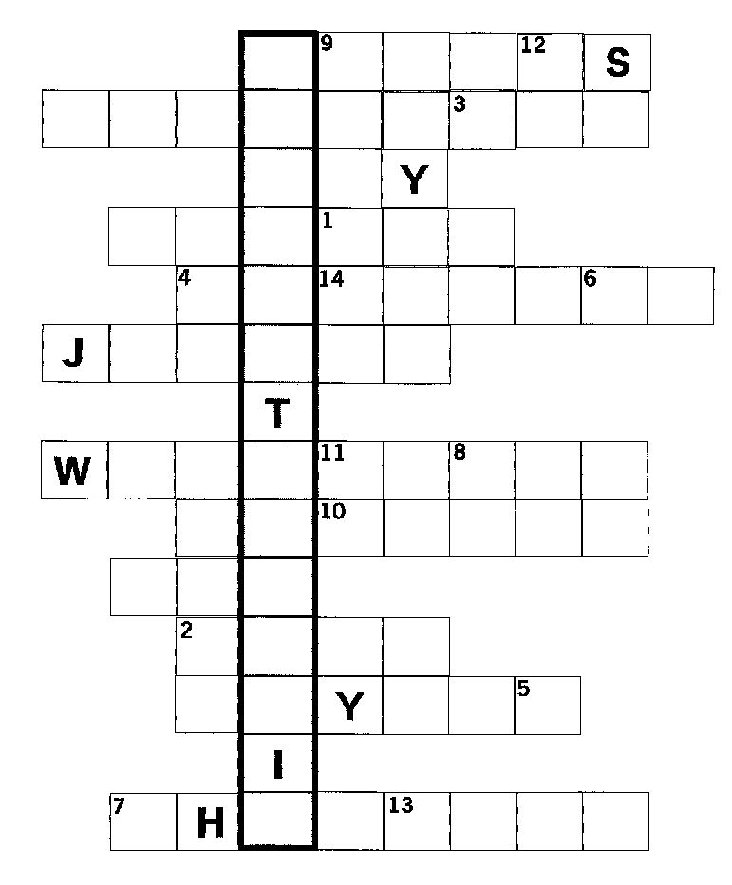
If you put the letters from the 14 numbered squares on the grid below, you will find the name of another Civil War personality who has not yet been mentioned:
