Put the title Development of Castles in your exercise book.

Read the information on the webpage.

Task One
1. Split the class into three groups, and hand out the picture-sheet ‘Development of the Castle’.

2. One group takes the first two pictures (‘Motte & Bailey’ and ‘Stone Keep’).
- Identifying development: The students find THREE disadvantages of the Motte and Bailey which were solved by the Stone Keep (another way would be to think of three ways Stone Keeps were better than the Motte and Bailey).
- Explaining development: The group then explains HOW the Stone Keep solved the problems of the Motte and Bailey.
3. The second group does the same for the ‘Stone Keep’ and the castle with ‘Curtain Walls’.
The third group does the same for the castle with ‘Curtain Walls’ and the ‘Concentric Castle’
4. Each group then makes a presentation to the class explaining HOW and WHY castles changed/developed over the 300 years 1066-1330.

Task Two
Working individually:
1. Write an essay: ‘How and Why Castles developed, 1066-1330’. This is not easy.
2. Start by writing: ‘The Motte and Bailey castles hastily erected by the Norman Barons had various limitations…’, then describe the weaknesses you identified.
Then write: ‘Stone Keep Castles were developed which solved these problems…’, and describe how and why Stone Keep Castles were better than Motte & Bailey castles.
3. Next, write: ‘Even so, Stone keep Castles had various limitations…’, then describe the weaknesses you identified.
Then write: ‘Curtain Wall Castles were developed which solved these problems…’, and describe how and why Curtain Wall Castles were better than Stone Keep Castles.
4. Then, write: ‘However, even Curtain Wall Castles had various limitations…’, then describe the weaknesses you identified.
Then write: ‘Concentric Castles were developed which solved these problems…’, and describe how and why Concentric Castles were better than Curtain Wall Castles.
5. Finally, write a conclusion summing up how and why castles developed in the Middle Ages … perhaps, if you can, identifying an underlying principle?

Task Three
Working with a partner:
1. Discuss everything you ca: n see happening in the picture-sheet: ‘Life in a Castle’.
Development of the Castle
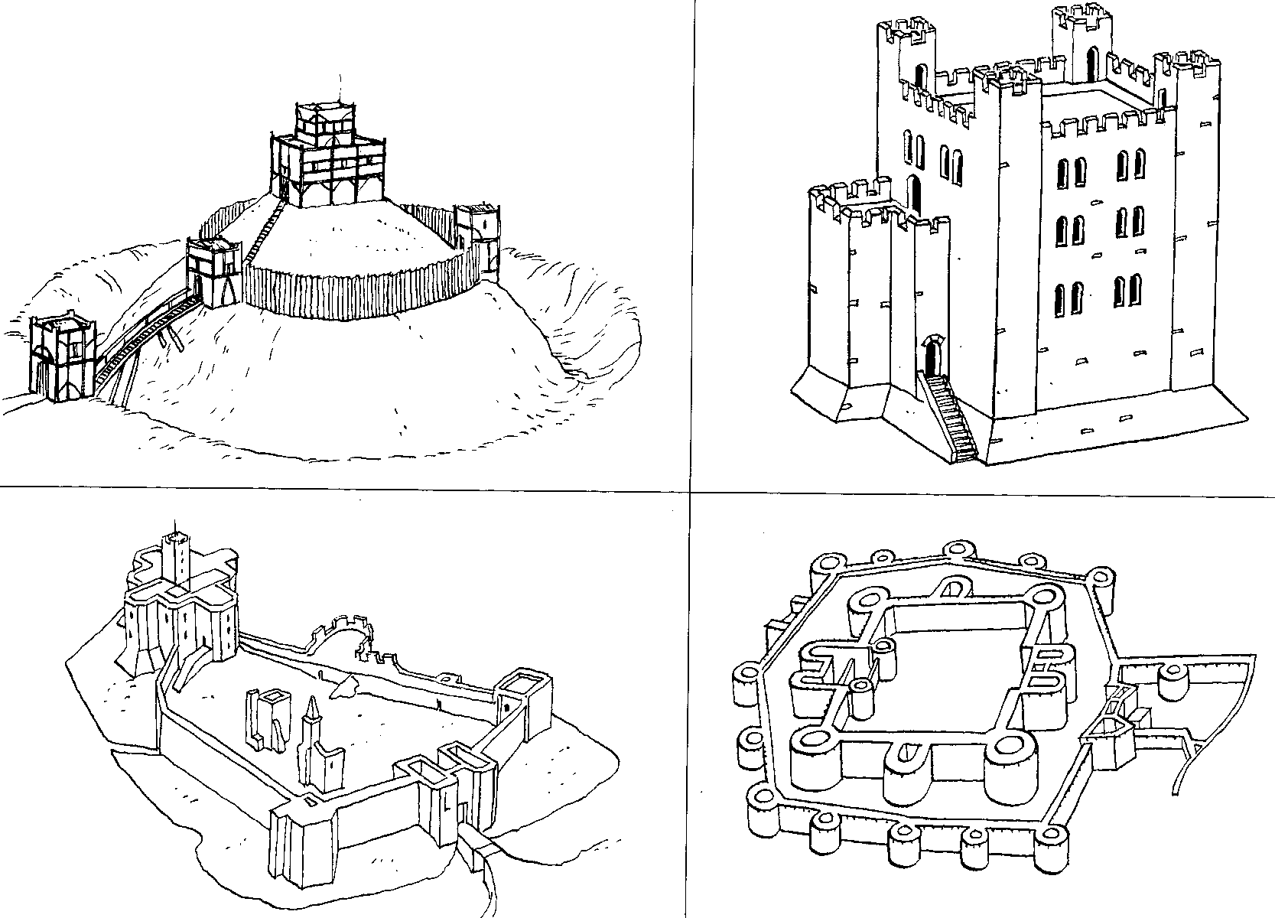
Motte and Bailey
Stone
Keep
Curtain Walls
Concentric Castle
Life in a Castle
