Put the title The Reign of Henry II in your exercise book.

§1 - The Achievements of Henry II
Task One
Working as a whole class, study the Introduction and Sources 1 and 2:
1. Discuss all the ways that ‘justice’ before Henry II had been unfair.
2. Do the discussion-sheet: ‘Punishments in the Middle Ages’.
3. Henry II remodelled the system of justice. Make a spidergram of all its key elements.
- On what principles was Henry’s new system based?
- How much better was it than the old system?
4. “Henry's changes to the legal system are arguably the most important development in the whole history of England.”
- Explain why I write this – explain WHY they were so very significant.
- Do you agree?

§2 - Henry II’s Government
Task Two
Working with a partner or in a small group, study the section ‘continued – Henry II’s Government’ and Sources 3 and 4:
1. Working with a partner or in a small group, discuss Source 3:
- List the things it says about Henry II (there are more than 10).
- For each statement, compare it against the facts you know about Henry, and say for each whether you agree or disagree with the statement.
- How trustworthy do you think this source is?
2. Working as a whole class, discuss Source 4:
- List the things it says about Henry II (choose the most important).
- For each statement, compare it against the facts you know about Henry, and say for each whether you agree or disagree with the statement.
- How trustworthy do you think this source is?

Coming together as a whole class;
3. Watch the clip from ‘A Lion in Winter’.
- How does Peter O’Toole portray Henry II?
- From what you know about Henry II, do you think that O’Toole’s portrayal is a good one? Did he ‘get’ Henry? (Remember to support any criticisms with facts and arguments.)
4. Henry says: “My life, when it is written, will read better than it lived”.
- What do you think Goldman meant?
- What do you think of this as an evaluation of Henry II’s reign?
5. Discuss: does Henry II deserve to be called ‘Henry the Great’?
6. Write your own evaluation of Henry II, supporting your suggestions with facts and arguments.

Punishments in the Middle Ages
Punishments in the Middle Ages were cruel. Pictures A-F show the punishments for fighting, nagging, selling bread that was underweight, trying to kill the king, stealing a cow, and rebellion.
Can you guess which punishment was given for each crime?
Because of the severity of punishments, many criminals escaped and became ‘outlaws’. England’s most famous outlaw is Robin Hood (though most historians doubt he ever existed).

A. 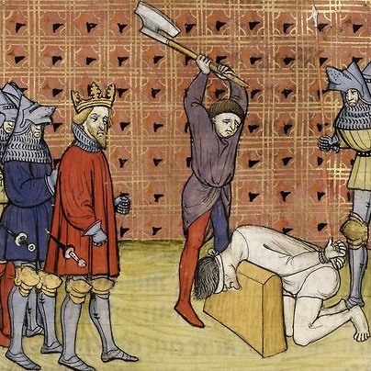 B. 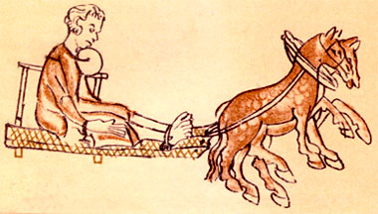

C. 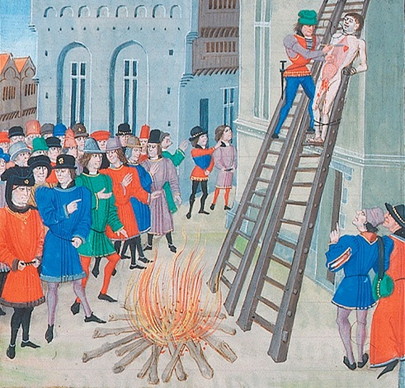 D. 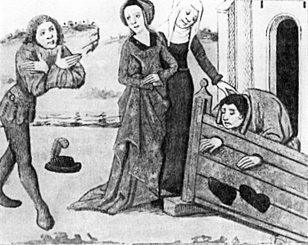

E. 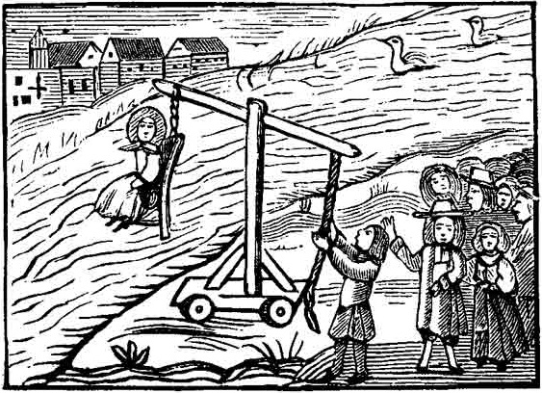 F. 