Put the title The Reign of Stephen in your exercise book.

§1 - The Reign of Stephen
Task One
Working with a partner or in a small group, study the Introduction:
1. Go through the events of Stephen’s reign. There are 14 identifiable dates. Use them to construct a timeline of events – if you wish, use the worksheet, The Reign of Stephen, to help you.
2. Discuss the events in your group or as a class:
- What date, do you think, marks the point when Stephen begin to lose control of the kingdom?
- Looking at the events, can you suggest reasons why Stephen lost control?
- Some historians have suggested that the reign was ‘anarchy’; does your list of events support this interpretation?

§2 - The ‘Anarchy’
Task Two
1. Working with a partner or in a small group, discuss Source 1:
- What evidence does it provide that the reign was a time of ‘anarchy’?
- What reasons does it suggest for why the reign fell into anarchy.
- How trustworthy do you thing this source is?
2. Working as a whole class, discuss Source 2:
- What evidence does it provide that the reign was a time of ‘anarchy’?
- Make a judgement; in your considered opinion, was the period 1135-53 a time of anarchy? Make a list of the facts and ideas which support your opinion.

§3 - The Causes of the Anarchy
Task Three
1. Working as a whole class, read the difficult section ‘Interpretations’:
- Read Source 3. Whom does RJA White blame for the anarchy; why.
- Read Source 4. Explain how it supports the idea that Stephen’s reign fell into chaos because the Feudal System was changing from ‘personal lordship’ to ‘the rule of law’.
2. Discuss as a class all the different reasons why government collapsed in the period 1135-53. Working either on your own, in a group, or as a whole class, draw a spidergram which shows ALL the reasons.
3. Make a judgement; in your considered opinion, WHY was the period 1135-53 a time of anarchy – which is the best explanation? Make a list of the facts and ideas which support your opinion.
Answers:
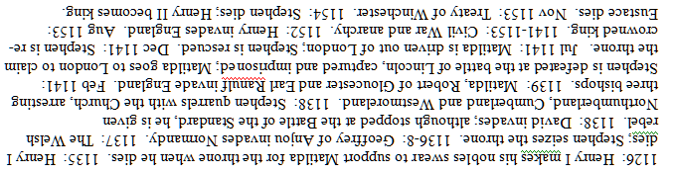
The Reign of Stephen
1126
1135
1136-8
1137
1138
1138
1139
Feb 1141
Jul 1141
Dec 1141
1141-1153
1152
Aug 1153
Nov 1153
1154

