Put the title Medieval Pilgrims in your exercise book.

§1 - The Positives
Study the Introduction and Sources 1 and 2.
Task One
Working with a partner or in a small group:
1. Share, look up, or ask the meaning of the following words: purgatory, pilgrimage.
2. Compare Sources 1 and 2, and find all the similarities. Does the fact that they correspond so closely make them more believable?
3. Make a list of all the ‘positives’ about going on a pilgrimage.
4. Play the ‘Pilgrimage Game’. When you have finished, discuss what it taught you about going on a pilgrimage, e.g.:
- How did you get most spiritual reward (i.e., in the game, score most points)?
- What expenses were involved?
- What was the most interesting thing you bought?
- What was the most interesting place you visited?
- How was your pilgrimage similar to, and different from, a modern tourist trip?

§2 - The Negatives
Study the Source 3 and the text ‘One Visitor to Rome’.
Task Two
Working as a whole class:
1. Make a list of all the ‘negatives’ about going on a pilgrimage.
2. Were pilgrimages, ultimately, a bad thing?
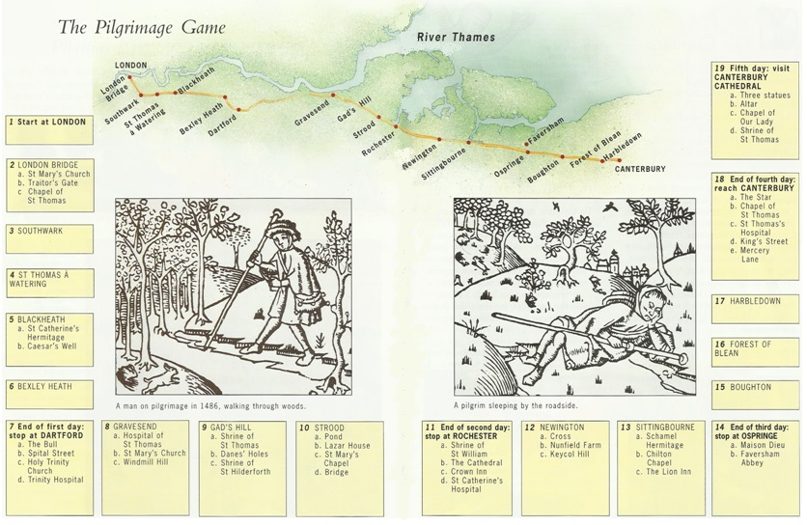
The Pilgrimage Game Instructions – I
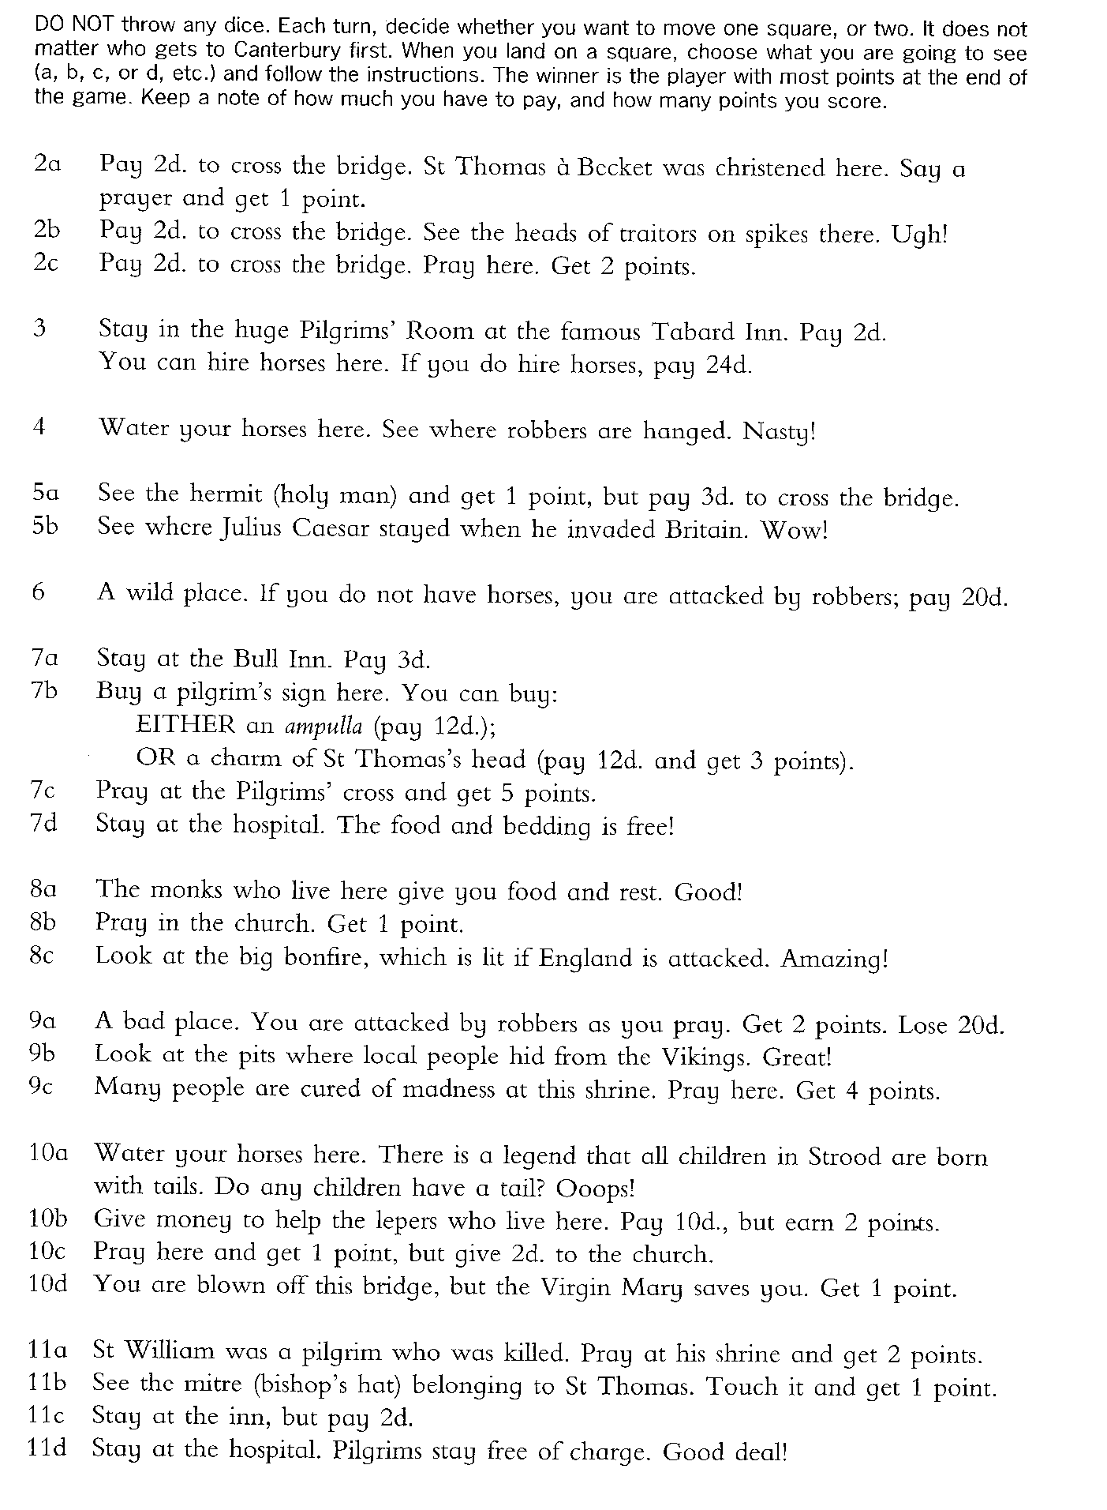
The Pilgrimage Game Instructions – II
