Put the title Medieval Woman in your exercise book.

§1 - How important were medieval women
Study sources 1-8.

Task One
1. Working as a whole class with your teacher, talk about each source in turn, discussing whether it portrays medieval women as oppressed, ignored drudges, or powerful, influential directors-of-their-own-destiny?
- NOTE: be careful, the evidence is all capable of different interpretation (see below), so do not just grab at the first idea that comes into your head.
- When you have completed this discussion, you may wish to look my my suggestions (upside down, below).
2. What impression, overall, do the Sources give of a woman’s life in those days?

Task Two
1. Working on your own or with a partner, answer the questions on the worksheet: Medieval Women. Note that many questions are illustrated in more than one source.

My Suggestions:
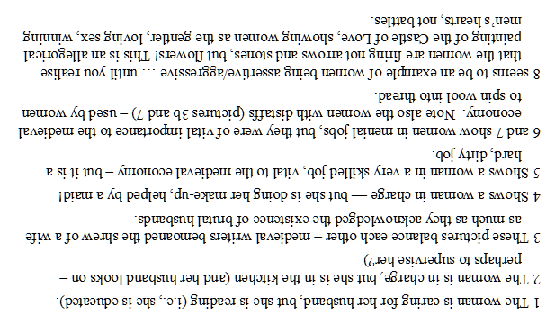
Medieval Women
Write the number of the picture/pictures which suggest that:

1. some women were educated and could read: ..…………………………………

2. some women were strong: ..………………………………………………………

3. some women did dull, menial jobs: ..…………………………………………….

4. women were important to the medieval economy: ……………………………..

5. some women were physically abused in the Middle Ages: ..………………….

6. women were supposed to be loving and gentle: ..………………………………

7. some women were in charge: .. …………………………………………………..

8. some women were very skilled: ..…………………………………………………

9. spinning was one of a medieval woman’s key tasks: ..…………………………

10. some women bullied their husbands: ………………………………………….

