Put the title William’s Invasion in your exercise book.

§1 - Extraction of information
Study Sources 1-8.

Task One
1. Divide the class into eight groups, assigning one source to each group.
2. Each group studies its assigned source, working out what is going on in the scene, making notes as a spidergram on the appropriate ‘Duke William Invades’ worksheet. (Students should think about ‘why’ as well as ‘what’ they can see.)

* * *

§2 - Collation of information

Task Two
1. Each group presents its findings to the rest of the class – you may choose to do so as simple verbal reports, or you can choose different ways, such as drama, powerpoint presentation etc.

* * *

§3 - Presentation of information

Task Three
1. When all eight groups have reported back, each group condenses their findings into a single sentence, which they write at the bottom of their ‘Duke William Invades’ worksheet.
2. Put up the sheets, in the correct order, on a display board or a wall. Read out the final ‘story’ to the class.
3. Write an account of William’s Invasion in your exercise book.
Duke William Invades
Make a spidergram of everything you can see happening in the picture:

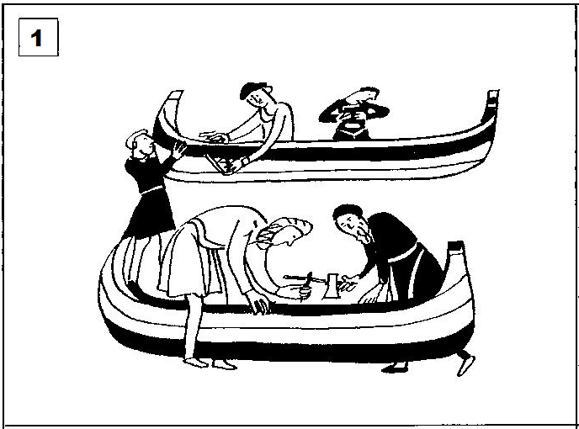

_________________________________________________________________________________
Do not write anything on these lines until your teacher tells you to do so:

…………………………………………………………………………………………………………

…………………………………………………………………………………………………………

…………………………………………………………………………………………………………

…………………………………………………………………………………………………………
Duke William Invades
Make a spidergram of everything you can see happening in the picture:

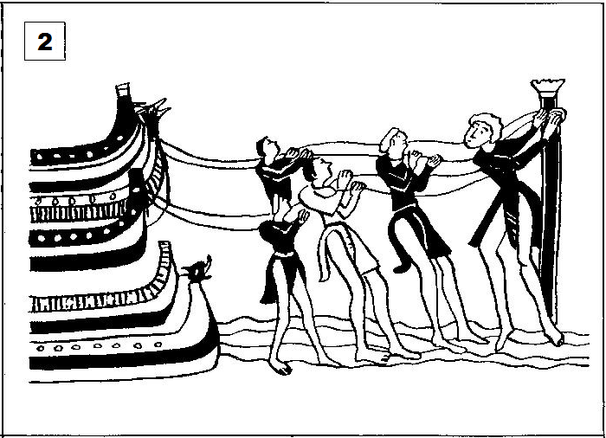

_________________________________________________________________________________
Do not write anything on these lines until your teacher tells you to do so:

…………………………………………………………………………………………………………

…………………………………………………………………………………………………………

…………………………………………………………………………………………………………

…………………………………………………………………………………………………………
Duke William Invades
Make a spidergram of everything you can see happening in the picture:

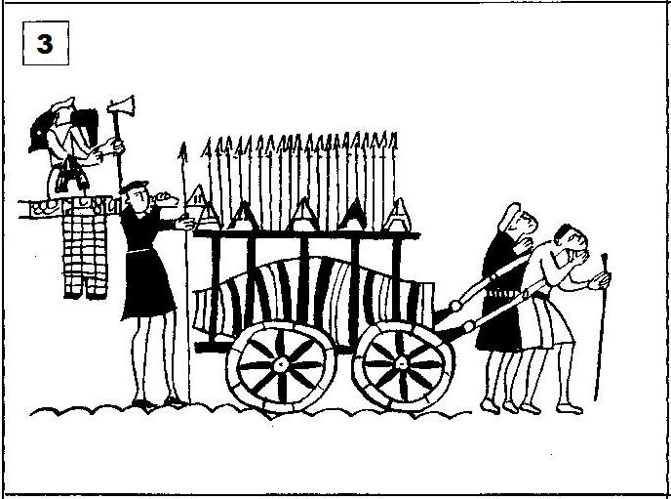

_________________________________________________________________________________
Do not write anything on these lines until your teacher tells you to do so:

…………………………………………………………………………………………………………

…………………………………………………………………………………………………………

…………………………………………………………………………………………………………

…………………………………………………………………………………………………………
Duke William Invades
Make a spidergram of everything you can see happening in the picture:

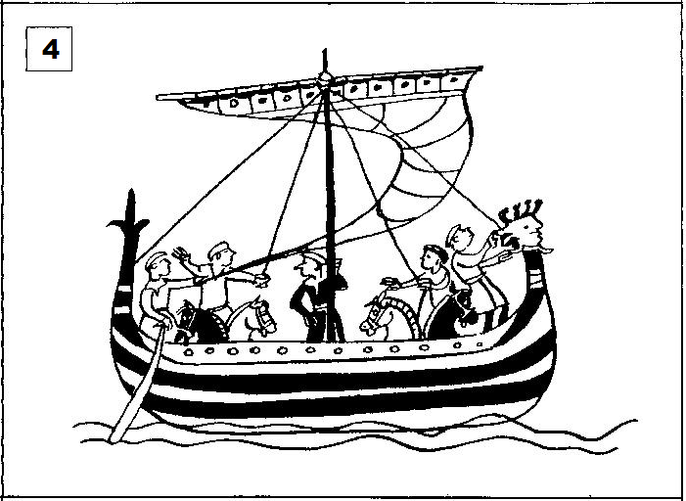

_________________________________________________________________________________
Do not write anything on these lines until your teacher tells you to do so:

…………………………………………………………………………………………………………

…………………………………………………………………………………………………………

…………………………………………………………………………………………………………

…………………………………………………………………………………………………………
Duke William Invades
Make a spidergram of everything you can see happening in the picture:

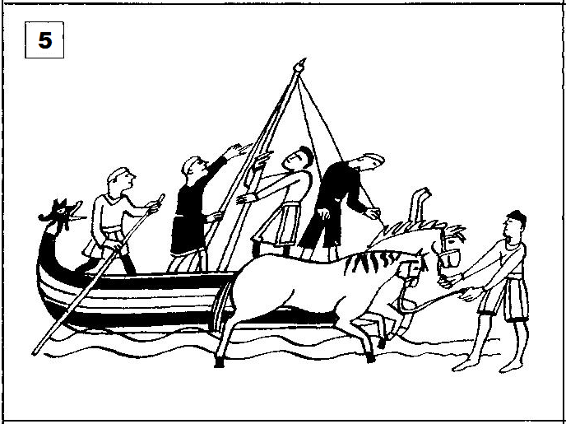

_________________________________________________________________________________
Do not write anything on these lines until your teacher tells you to do so:

…………………………………………………………………………………………………………

…………………………………………………………………………………………………………

…………………………………………………………………………………………………………

…………………………………………………………………………………………………………
Duke William Invades
Make a spidergram of everything you can see happening in the picture:

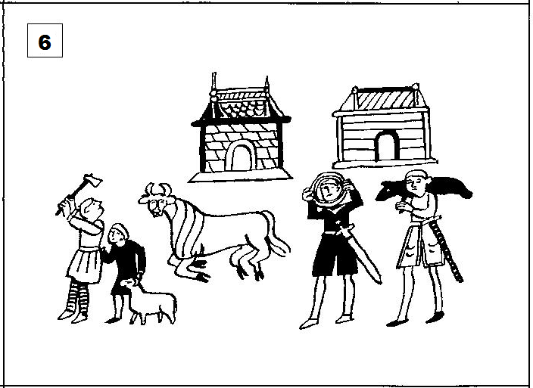

_________________________________________________________________________________
Do not write anything on these lines until your teacher tells you to do so:

…………………………………………………………………………………………………………

…………………………………………………………………………………………………………

…………………………………………………………………………………………………………

…………………………………………………………………………………………………………
Duke William Invades
Make a spidergram of everything you can see happening in the picture:

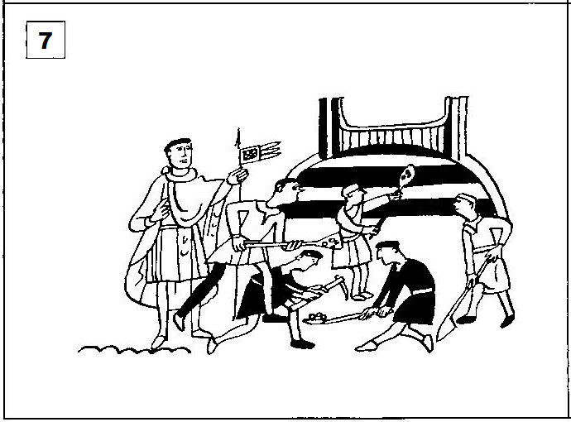

_________________________________________________________________________________
Do not write anything on these lines until your teacher tells you to do so:

…………………………………………………………………………………………………………

…………………………………………………………………………………………………………

…………………………………………………………………………………………………………

…………………………………………………………………………………………………………
Duke William Invades
Make a spidergram of everything you can see happening in the picture:

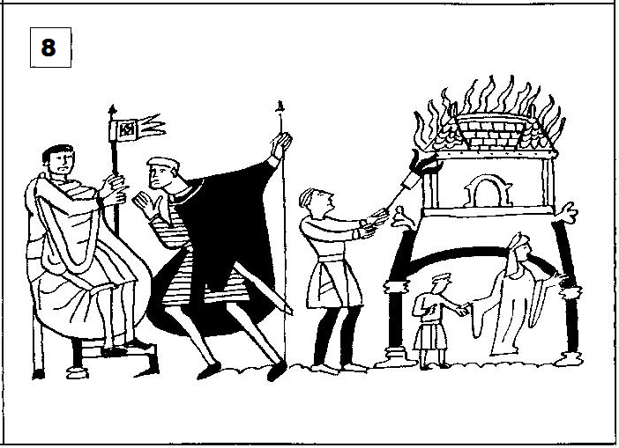

_________________________________________________________________________________
Do not write anything on these lines until your teacher tells you to do so:

…………………………………………………………………………………………………………

…………………………………………………………………………………………………………

…………………………………………………………………………………………………………

…………………………………………………………………………………………………………

