Put the title The Feudal System in your exercise book.

§1 - Hierarchy
Read the Introduction and look at Source 1. A ‘hierarchy’ is an order of rank.

Task One
Working with a partner or in a small group:
1. Discuss modern organisations which have a hierarchy – does modern society have a hierarchy?
2. Using the Introduction, make a list of what each person gave to those below them, and what they got in return. Use this information to complete the worksheet ‘The Feudal Hierarchy’.
3. Working on your own, do the worksheet ‘Who’s Who in Feudal England’.

* * *

§2 - Opinion
Starting out as a Conqueror gave William a head start – he got the chance to say that all the land in England belonged to him, and to organise as he wished.
Even so, the feudal system was incredibly diverse and complicated … to the point where some

Task Two
1. Working in a small group, do a Google Image search for the "Feudal System". This will reveal many different diagrams trying to explain the Feudal System.
In discussion with your group, choose:
- The one you think is most simplified
- The one you think is most complicated
- The one you think best explains the Feudal System
2. Working in your group, read the BBC Bitesize Interpretations webpage, and discuss the questions at the bottom:
- What is your interpretation of the power of the king at the start of the Middle Ages?
- How much truth is there in the idea of a 'feudal system'?
- How much power did the king really have – was he really all-powerful?

The Feudal Hierarchy
Complete the boxes below to complete this diagram of what each person gave, and what they promised, for their part in the feudal system:

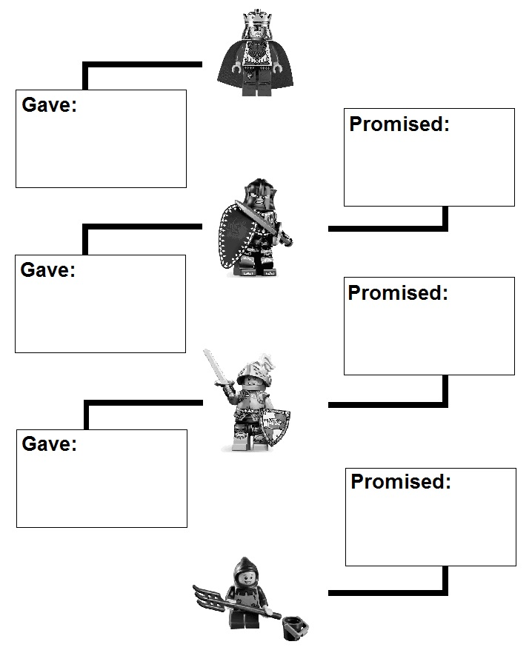
Who’s Who in Feudal England?

Answer the following questions:

